Lambton Presbytery United Church Centre
Annual General Meeting 2016-2017

Lambton Centre is a camp-based community partner dedicated to enriching lives through outdoor education and recreation.

Annual General Meeting 2016-2017
Lambton Centre Staff
Executive Director: Rick Boerkamp
Office Administrator: Debby Merritt
Property Manager: Ben Gates
Custodian: Randy Scott

Lambton Centre Board of Directors

Chairperson: Betty Knight
Personnel Director: Penny Cox
Fundraising Director: Dylan Cox
Financial Director: Jim Krall

Chair of the Lambton Centre Board of Directors
2017 has been another year of growth at Lambton Centre. It was a year where we saw continued growth within our summer camp program with many of our camps full to capacity. It was a summer where we rediscovered the beauty of the beach and shoreline through phragmites control program. The Board of Lambton Centre numbers remained small but dedicated to seeing the ongoing success of Lambton Centre. It was a year where we were able to fill our full-time staff complement at Lambton Centre.

Our camping program in 2017 saw an increase in our camping numbers in both summer camp and in our Splash – Day Camp program. To enhance our camping experience, we added to our low ropes program. The children still enjoy playing on the new playground. This summer, Rick Boerkamp acted as the camp director and was in direct support of camp leadership team. With the change in our senior camp staff, some adjustments will be made for the upcoming year. This year many of our campers and their families completed surveys to let us know how we can improve our summer camp program.

Early in 2017, the Board of Directors hired two new full-time staff. Ben Gates was hired as our property manager. Ben’s enthusiasm makes him a welcome addition to our team. Ben continues to develop his expertise as a property manager. We would like to thank the Tuesday volunteers for their assistance is helping Ben complete tasks and develop his knowledge base. The Board of Director also added Rick Boerkamp, as our Executive Director. Rick’s family has been involved with Lambton Centre for many years, as campers and summer staff. Rick will focus on programming at Lambton Centre, public relations, and will assist the Board of Directors in developing a plan for the future success of Lambton Centre. As this is a new position at Lambton Centre which is constantly evolving to meet the needs of Lambton Centre. We feel that both Ben and Rick are excellent additions to our team.

Debby, in the office, continues to be a wonderful asset to our team. Debby is an excellent source of knowledge about Lambton Centre. She has excelled at securing funding for Lambton Centre through many grant applications. Debby was instrumental in helping secure funding for the phragmites control and was an outstanding liaison with the Lambton Shores Phragmites Committee. Randy Scott has continued to be our Custodian extraordinaire. Randy has been working hard to keep the camp in tip top shape.

Moving forward, we as a board are attempting to communicate better with members of presbytery and to the community at large to show them the beauty of Lambton Centre through day recreation programs, summer camp and seasonal camping. The Board of Directors, are still a very small hardworking group. This year we said good bye to Brenda Roby and John Yates from their positions on the Lambton Centre Board of Directors. We would like to thank these members for their time and dedication they both have for Lambton Centre. The Lambton Centre Board of Directors are always looking for new members and if anyone is interested in volunteering please do not hesitate to contact the board directly at our new dedicated email at theboard@lambtoncentre.com.

As the Lambton Centre Board looks ahead, we are awaiting to see how the restructuring of the United Church will affect Lambton Centre. We are always looking for new and innovative ways of fundraising, community involvement, outreach, and partnerships with community groups, churches, and government agencies in living our mission. We invite you to join us on this adventure.

Betty Knight, Chair of Lambton Centre Board of Directors
The Corporation of Lambton Presbytery United Church Centre Annual General Meeting Agenda
January 21, 2018
12:30 pm
1.0 Call to Order and Welcome

2.0 Opening Prayer

3.0 Introduction of Guests

3.0 Approval of the Agenda

4.0 Approval of the Minutes from the 2015-2016 Annual General Meeting

  - Business Arising

  - Communication with Churches

  - Fundraising Efforts

  - Financial Statements

  - Financial Statements for 2016-2017 Auditors

  - 2017-2018 Budget

7.0 Appointing Auditors for 2017-2018

- Nominating Committee Report

- New Business

  - Looking Forward to 2017-2018 – upcoming plans and goals

10.0 Adjournment

The Corporation of Lambton Presbytery United Church Centre Annual General Meeting Minutes

January 22, 2017

- Call to Order and Welcome 1:20

- Opening Prayer

- Count of United Church Members – more than 25

3.1 Introduction of Guest - Mike McDonough of the accounting firm of Hume, Mayer, McDonough & Little LLP

3.2 Approval of the Agenda Motioned by John Yates, Seconded by Doug Beattie. Motion Carried

4.0 Motion to approve the minutes from the 2015-2016 Annual General Meeting was made by Jim Louks, seconded by Dave Robinson. CARRIED

  - Business Arising

5.2 Communication with Churches – Betty Knight, Board Chair, indicated that the Board has been trying to make contacts with all Churches, however if anyone would like to be the contact person for their church to facilitate that communication, there is a sign-up sheet at the back of the meeting. Request made for additional ideas to improve communication with churches.
Suggestion by Rev Marilyn Townsend-Smith that camp comes to churches to put on presentations to help improve awareness. Betty agreed and also mentioned camping Sunday and that it would be helpful to encourage ministers to promote this in their churches.
5.3 Fundraising Efforts
  - Appreciation expressed to Central United for support of our Turkey Dinner/Fall Night. Also thanks to Board & Volunteers
  - Donation Tree – Encourage people to donate and get acknowledgement for their donations. Donation tree was available for attendees to view. Also mention of engraved stones available for larger donations.
  - Dylan Cox reported – looking forward to continuing our fundraising success this year. The playground is in and we were able to raise most of the funds needed for that. The trivia night fundraiser wasn’t a great financial success. However, we will hold it again this year as it was enjoyed by those who attended. The plan is to advertise it more and hold it on a night that does not coincide with other area trivia nights. We are looking at bringing in a large fundraiser. If anyone has ideas for fundraisers they are encouraged to make suggestions. Assistance at fundraisers is also appreciated. Silent auctions at fundraisers has also supplemented income from various fundraisers
  - Corunna Church has offered to host this year’s Chicken barbecue.
  - We now have a board email. People can email directly to the board with suggestions. The address is theboard@lambtoncentre.com

6.1 Financial Statements for 2015/2016:
Mike McDonough of the accounting firm of Hume, Mayer, McDonough & Little LLP reviewed the auditor’s report. They did not find any issues at all. Staff were co-operative, records were readily available and Debby in office is doing a great job in this regard. There were some major purchases this year which were good in following the camp mandate. The balance sheet is much improved this year over last. The equity in the camp went up over $40 000. There has been a significant steady increase over the last couple of years. The board and the membership are to be commended in that regard. Last year we had a deficit. This year we have a surplus. It was a good year and the Board is doing a good job of managing revenues and expenses.

Jim Krall thanked Mike for financial report

Motion to accept the report was made by Carol Oostenbrink, seconded by Louise Hall, Carried.

6.3 BUDGET 2016/2017
Report: Jim Krall, Director and Chairman of Finance, presented the 2017 Budget to the members. Jim went through each line total.
Summary of Discussion and Suggestions:
Income:

- Reviewed income anticipated from sources such as trailer court, gate fees, group fees,
- Children’s Centre does need some renovations and upgrading. We have discussed contacting the Rotary Club to see if they would consider new donations to improve that facility. We are also looking at approaching local youth groups such as the Girl Guides, Scouts etc. to see if they might be interested in using this facility. In the farmhouse we did some work upgrading mattresses, and mattress covers and purchased the new range for the main facility. Budget is based on us getting 4 or 5 additional rental nights this year over last year.
- Summer Camp – no tuck shop revenue for this year. We have now included that in the camp fee so that all campers will be able to enjoy the tuck shop. Splash Camp – this year we included an additional splash camp that cost us an additional bus fee. Next year we are going to charge a bus fee of $10/week to assist with this cost.
- Grants – we are constantly trying to get more grants. There were some grants at the plants that you had to have someone at the camp working there to get the grants, however Debby has been applying to many different grants to assist with camp costs.
- Fundraising – is ongoing. The last couple of years during the chicken dinner it has poured rain so the attendance has been down quite a bit. Selling tickets ahead of time we are hoping will encourage people to come and provide that revenue regardless of the weather. Clarification was provided on budget report that “BBQ” covers both the chicken and the beef barbecue fundraisers. We are looking at upgrading the website to facilitate online paying of some items. Making this available for fundraising may be available as well.
- Presbytery Grant – There is concern that we cannot depend on the Presbytery grant. John Yates is recommended that we look at ways to work that out of the budget. Perhaps churches can each make a donation now while they are operating.
Other discussion included:
- that some churches already give additional financial support.
- concern expressed that there is a real possibility that Presbytery will cease to exist and then that is a pot of money that will also cease to exist.
It was acknowledged by Board that being dependent on that grant is not wise and that alternatives are being considered.

Expenses – we are continuing to monitor expenses such as keeping heat down in buildings when not in use. Explanation provided that the hydro expense in Children Centre line also includes several trailers and the washroom facility. The Manse hydro expense still exists but heat is as low as possible.
  - Question asked on why the Manse isn’t being rented out. Response – a position is being offered which would include residence in that building although other uses of that building have been discussed.
  - Question on hydro issues in trailer court. Concern about busses being burned out. Dylan explained that more trailers were put on one line than the other. A new line was discussed with previous property manager. This will need to be followed up to determine best plan going forward.
  - Credit card charges explained. Most of the expense is the result of costs resulting from other people paying Lambton Centre by credit card.
- Capital Expenditures Capital Expenditures – some of the cabins will need new rooves, phragmites removal is an ongoing expense over the next 3 years for it to be effective. Some of this expense will be covered in grants.
- Repairs and Maintenance – increased, rooves needing replacing, Children’s Centre needing renovating. Purchased new tractor. Money that Dave Robinson has been raising has gone towards the tractor. As a result of his fundraising we currently have approximately two years of funding for these payments.
- Staffing – still looking to hire a new Property Manager. We have hired a new custodian who is working out very well.
  - Recommendation made that staff quarters be inspected to ensure cleanliness before staff leave.
  - Maintenance – Possible co-op student position being considered
  - Pool – question on lifeguard coverage. Betty explained difference between Class A and Class B pool and why now the budget is less and why we no longer need a lifeguard for the campground when summer camp is not in session. Louise indicated that had been check into before and inquired if that that had been cleared with insurance as well. This has been done.
  - Question – Could summer student be available to monitor gate on weekends? Response, that we would have a full time staff member available on site during the weekends as well as during the week.
  - Question - What will happen if we don’t find someone to fill the roles that are posted? Response from Betty – we want the right people, not just anyone and will continue to search for good candidates. We have been blessed by the great support from the Tuesday Volunteers and our amazing new custodian.
  - New Jr Counsellor position. These will be counsellors who have gone through our LIT program. Our set protocol remains that counsellors will be 17 by December 31st but this new Jr counsellor position allows us to keep good young people involved in the camp.
- Summer Camp – we are putting money towards a new low ropes course. Our previous low ropes, much was attached to trees that are no longer there. We have looked into the low ropes and $8000 doesn’t actually get you very much. The cost includes training on using the system. Question on reduced amount in training budget. We will have to look into reason for reduced training budget.

Request made for any further questions on budget. Camper requested that harrows get run over roads in camp ground. A volunteer agreed and it will be done.

Motion to accept the budget for 2017 made by Maxine MacDonald and seconded by Bruce Forbes, Carried.

7.0 Motion to appoint Auditors for 2016-2017 made by John Yates, Seconded by Louise Hall – Carried.

8.0 Nominating Committee Report
Right now we need everyone to attend all Board Meetings to have quorum. Really need additional members and are accepting applications. According to general conference new members have to be voted on at a Presbytery Meeting if not done at the AGM.

Motion for John Yates to join board made by Edith Widdowson. Seconded by Larry McLaren. Carried.
Jim Krall has completed one 3 year term and will be returning for a second 3 year term.

9.0 New Business

Report from Chair – Betty Knight
Looking forward we are currently working on recruiting new staff: a Property Manager and an Executive Director.
- We are currently in the process of interviewing candidates for the position of property manager. The Tuesday Volunteer Group has been helping Lambton Centre with maintenance issues and snow removal since Rick left his position. We would like to thank everyone for their dedications and assistance in this matter. Hopefully we will have Property Manager in position within the near future.
- The Executive Director position will help us provide day to day supervision and direction at The Lambton Centre. The Executive Director position would also function as our Camp Director for 2017. The income for this position will be derived from the anticipated increased revenue from increased fundraising opportunities and increased exposure of the camp to groups in Lambton County. We need to look at welcoming new groups to our Centre. A Description of the Executive Director position was available on back table. If we don’t hire an appropriate person for this position we will hire a summer camp director as done previously.
- As a Board we need to work on recruiting new member and volunteers. We need new board members, volunteers to help with fundraising opportunities and we need more help with maintenance at Lambton Centre. If anyone has suggestions, please let us know. Also request made that those in attendance please talk to their congregations – we would love to have people join us as volunteers and directors.
- Fundraising we are always looking for new and innovative ways to raise funds to help support the Centre. Ideas are always welcome. We are particularly looking for large return fundraising ideas.
- The Lambton Centre Board is also looking at suggestions of other groups to try to partner with to encourage weekend rentals. Potentially we could offer program support to these groups on weekends. Groups currently being considered include Big Brothers/Big Sisters and the Children’s Aid Society of Sarnia Lambton. Any other suggestions and contacts would be appreciated.

Open Discussion -other comments, concerns or suggestions?

- Individual stated she is impressed with the board and attendees who are so committed and caring of camp. Thank you.
- Question about the addition of Splash Week and if there was still an increase in overnight numbers. Dylan indicated that we did have an increase in overnight campers plus increase overall numbers because of splash weeks.
- Question about return of Choral Camp –they are not returning

10.0 Motion to adjourn made by Judy Forbes Seconded by Dave Robinson
Meeting adjourned at 3:07

Reminder of Circle the Centre weekend – May 27th & 28th

2017 Summer Camp report
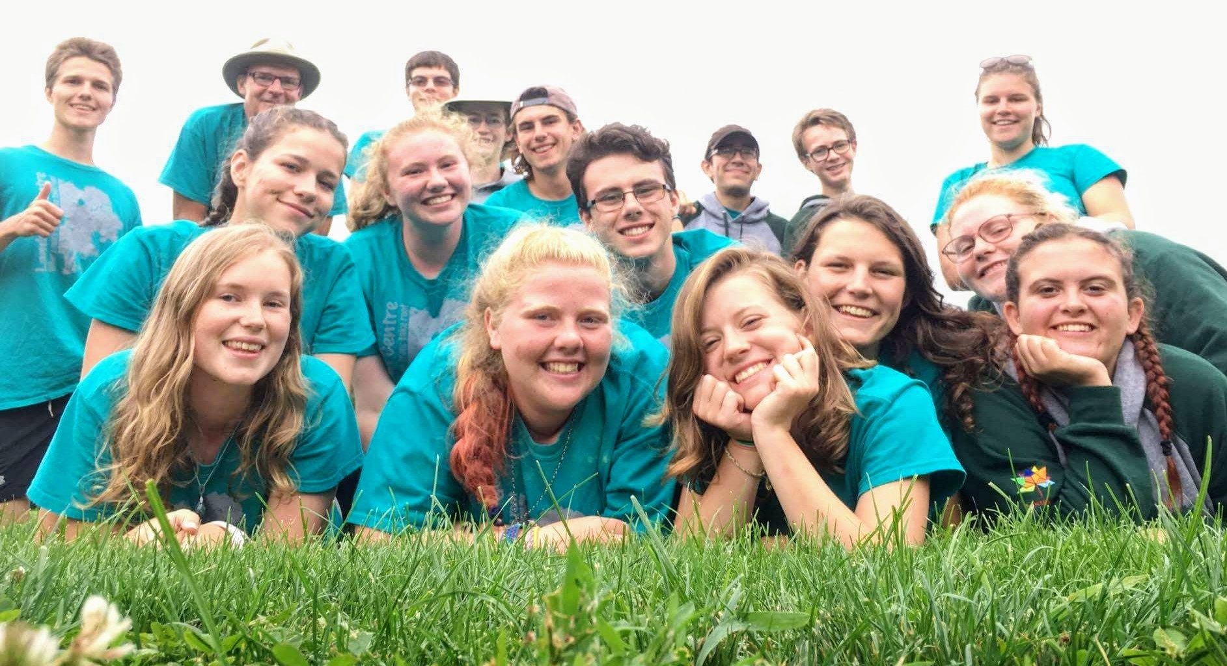
This was a learning year for myself as the new Executive Director. Working through the different programs from Outdoor Education in June and Summer camp in July and August had me working hard to learn and keep up with the programs.
Although we had a number of staffing challenges over the summer, in the end we had an exceptional team. On many occasions they rose to the challenge of welcoming and assisting new staff members mid-stream and/or learning our program and engaging the campers. When new staff came for a week they always felt welcome and an integral part of the staff. We had a very eclectic group of counsellors this year and I am very proud to have been able to work with a group of young people who allowed themselves to be challenged and grow, both as counsellors and individuals. One individual commented that they had never been at a camp that did not have any clicks. We were truly a team.
The staffing challenge, where we did not know how many staff we had going into the summer, made it difficult to judge camp capacity in many cases. Next year I will have a better handle on this but I also hope to be able to recruit counsellors earlier and figure out a way to keep them for the whole summer.

Program Directors- Lexie Boerkamp and Sarah Knight  Christian Educator/L.I.T Coordinator. - Dawson Strangway  Healthcare/Integration Coordinator - Harley Linton  Counsellors-Hailey Knight; Jewel Boerkamp; Aaron Devereaux; Kaity Pitcher; Andrew Leliveld; Douglas Thibert; Steven Gilvesy; Anne Thibert; Nicole Delmage; Taylor Pedersen; Catherine Linger; Charlotte Berube; Emma Brooks; Grace McNulty; Cameron Hilker  Lifeguard - Bethany Ferguson  Cook - Jennifer Humphries  Assistant cook -Hailey Finch | An Exceptional Team

In 2017 student grants were available for some positions which certainly helped with the bottom line. In 2018 and the introduction of the new minimum wage, Lambton Centre will be competing against jobs in the community that can pay much better than a summer camp can pay. As we look ahead at the registration fees for 2018, the Board, staff and I are striving to find a balance that keeps camp affordable for families and yet allows us to meet the ever increasing pressure to cover our expenses.

Outdoor Education
This spring we hosted 17 school groups (691 youth).
I distributed an evaluation to each teacher following their visit.
- When asked how they first heard about the program 100% identified peers.
- 71% of the respondents said that they had brought students in the past.
- 71% found it easy to choose programs. I found it challenging to work out programs when there were multiple groups on a single day. I will be looking at ways to make this work easier for next year. Some groups found some activities to be challenging. Next year I would do more work with the staff to help them adapt activities to the specific group. Using the GPS for geocaching can be challenging and some staff also struggled to understand how these worked.
- When asked about the enthusiasm of the staff. 57% gave the highest rating 28% gave the 2nd highest rating. These ratings increased as staff became more comfortable with the program.
- When asked about our facilities respondents rated all the following as very positive:
  - Visual appearance of the facility
  - Cleanliness of facility
  - Physical condition of the equipment and buildings
- Most popular activities included: Archery; Team building; Geocaching: Instincts for survival; Low ropes. These activities were rated as either “excellent activity good educational value” or “kids were engaged and had fun”

Testimonials
- Excellent activities that are timed well. Excellent organization!
- They need to be busy when they are waiting their turn on the archery. Geocaching was difficult!
- There could be a lot of awesome connections to the science curriculum for all grade levels.
- We thoroughly enjoyed all of our activities and were completely satisfied. Possibly a drama-style activity could be added to your selections? Not sure if it's really needed???

Reflection on Outdoor Education
Keeping activities fresh and interesting is important, especially for returning groups. For 2018, we will go over activities to keep them current and look at ways to incorporate curriculum links to create a stronger education focus.
In December, I started marketing the Outdoor Education program through the local Boards of Education as well as to all the teachers who have used our program in the past.

Summer Camper registration
Campers RFTR Campers Counsellors Program staff
Splash 1 69 0 10 1
Sr. Co-Ed week 13 2 6 4
Video Game Week 29 2+1 11 2
Leader In Training 2
Splash 2 71 0 11 3
Little People’s Week 20 1 6 7
All Girls Week 47 2 10 3
Sports and Arts Week 38 2 10 2
Total campers for the summer + 289
RFTR = “Reach For The Rainbow” A program to support campers with a disability.

Quality Improvement
In addition to learning the program, I was also very interested in evaluating our program for the purposes of continuous quality improvement. At the end of each week I sent out a survey to all the participants asking for their feedback. In total, I sent out 289 surveys and received 46 responses.
Our strongest response to the survey was at the beginning of the summer. I will look at ways to add an incentive for people to complete the survey. Perhaps providing a draw for people who participate in the survey after each camp.
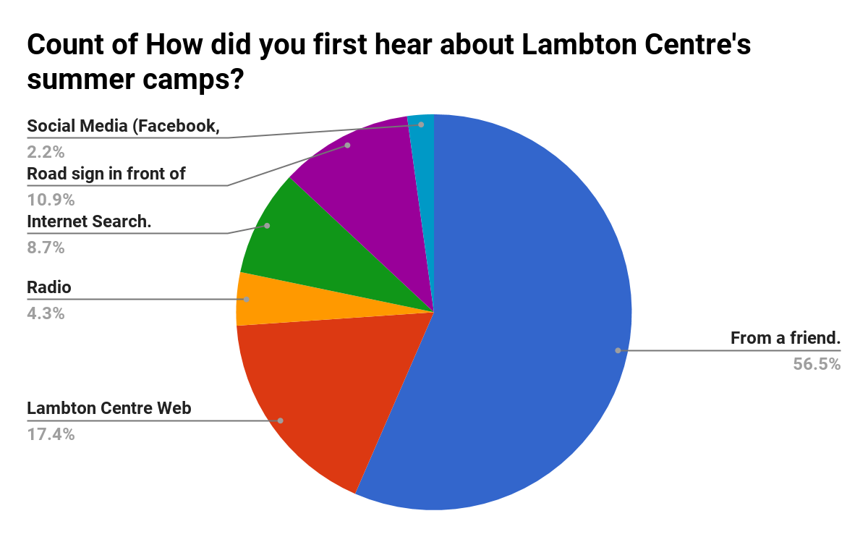

How did people first learn about Lambton Centre and our summer programs?
56% learned about Lambton Centre’s camps from a friend.
26% Use the internet to find our web page. It will be important to maximize our online marketing.
10% saw our road sign and followed up.
I also found the road sign to be helpful for recruiting staff.

Reflection on the Registration process.
How easy was the registration process? 80% gave highest rating. But there were people who had some difficulty with the process. In the coming year we will look at ways to reduce the steps needed to register. We will also look at consolidating the documentation to reduce confusion and ensure all the information needed is provided up front.

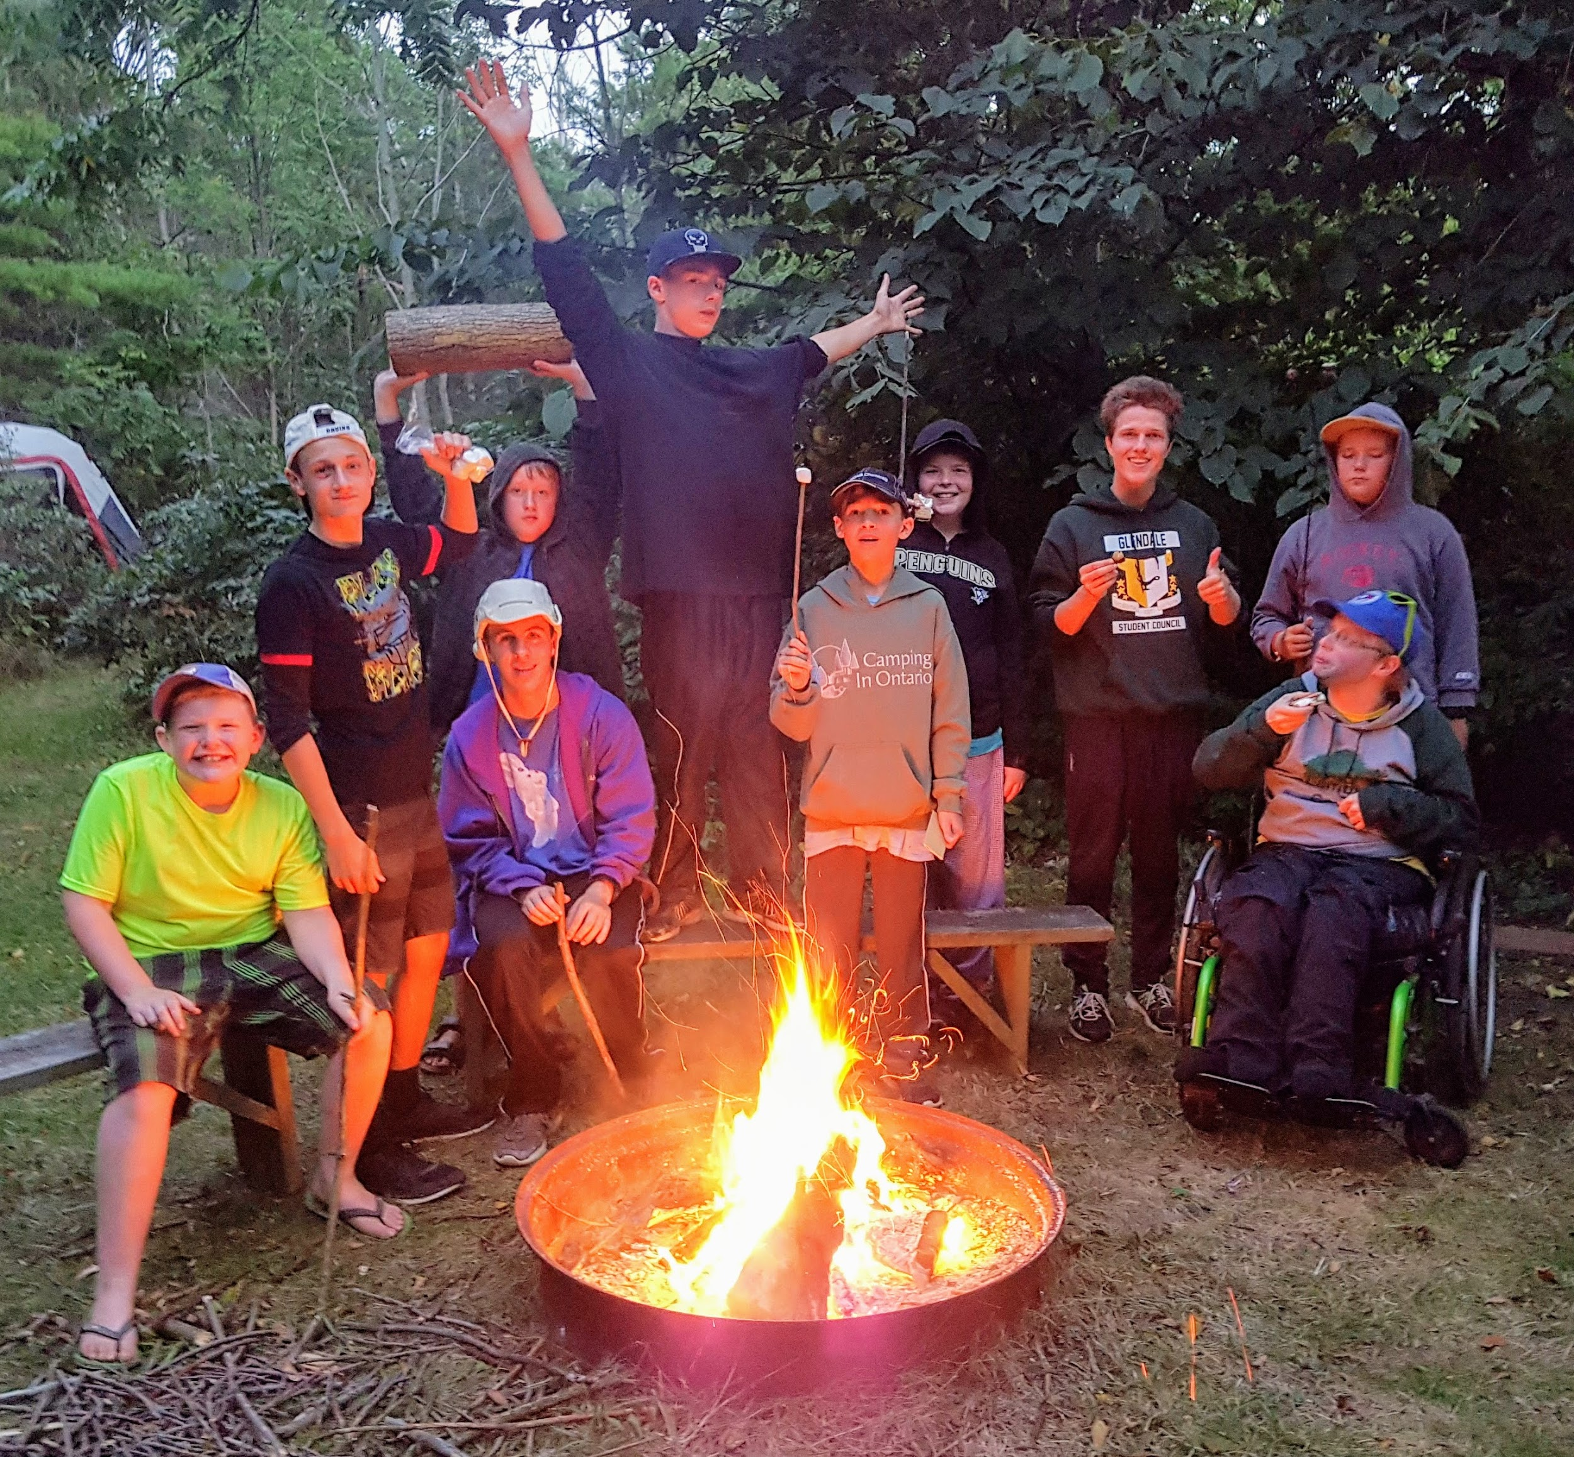
Inclusiveness
This year Lambton Centre again partnered with Reach for the Rainbow and Community Living. Through these programs 10 individuals were able to have a fantastic camp experience and one individual was hired as kitchen support staff. The training offered by Reach for the Rainbow helped our staff to focus on each camper’s abilities rather than their disability.

Staff responsiveness to parents and concerns
How friendly were the staff? 84% gave the highest rating. I found our summer camp staff to be very good at working with parents and campers. I had several comments from parents saying that they appreciated that I was also available and present with the campers.
How helpful were the staff in responding to questions or concerns? 71% highest rating 23% second level rating out of 5. Considering that most staff were new and that this was my first season, I am quite pleased with the feedback. With all concerns that were brought to my attention, parents were satisfied that their concern was understood and the issue was resolved and followed up with appropriate feedback.

Feedback on the Facilities
Comments from both parents, seasonal campers and visitors (at the August BBQ) have been very positive regarding the appearance of the facilities at Lambton Centre
30
25
20
15
10
5
 | Grounds |  |  | Washrooms |  |  |  | Cabins |  |  |  |  | Dining Hall/Kitchen
 |  | Exceptional , Close attention to detail and our particular needs.
 |  | Was clean and well organized
 |  | Passable but could use better attention to details
 |  | Needs improvement, not clean, problem with facilities

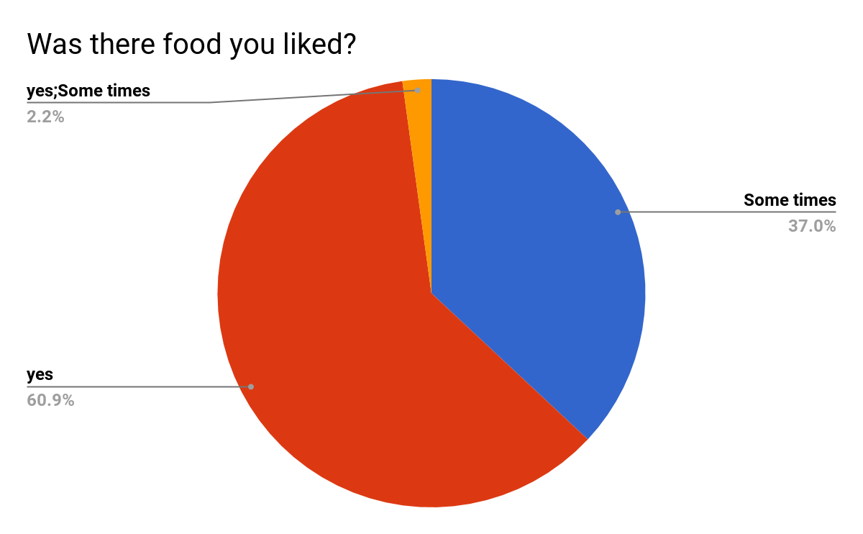
Camp Food

Over all campers liked the food. In reviewing the cook’s experience, I found that the job of cook can be overwhelming at times and having extra support in the kitchen was most valuable. Lambton Centre partnered with Community living to hire an assistant cook for 12 hours a week.
A volunteer also provided support 2-3 hours a day for an average 3 days a week. This volunteer helped in the kitchen and picked up groceries. The cook this year was very good at determining portions and making use of leftovers. At the end of the summer there was minimal food left over and the cook stayed under budget.
Moving forward -
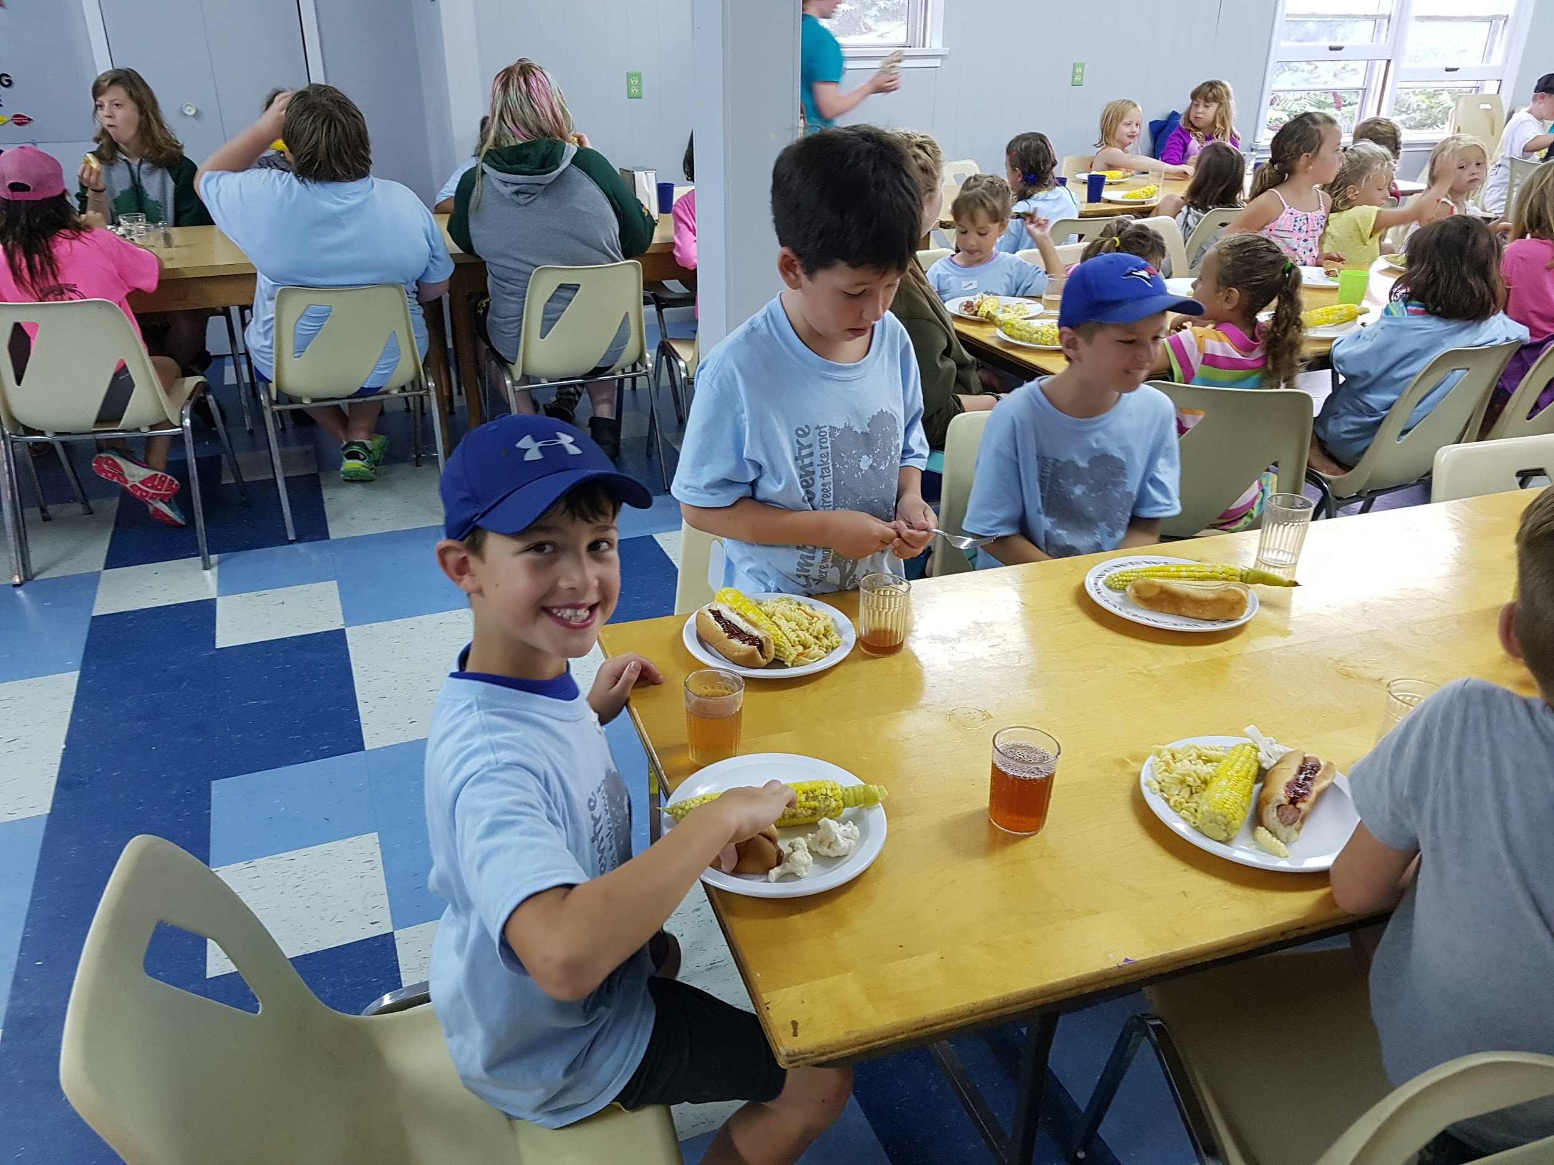
- I would structure the menu a little more to ensure a more balanced menu and to better accommodate special diet requirements.
- Consider the possibility of recruiting a student from a culinary program as a co-op placement.
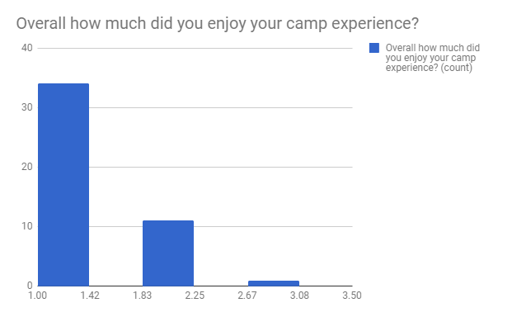
Overall camp experience was rated out of 5 with 1 representing the highest rating. 74% gave the highest rating. The graph is the number of respondents who selected a particular rating of 1, 2, or 3.
I evaluated individual events to identify the events that generated the most excitement for campers. The top rated activities included:
- Archery
- Swimming
- Water games
The activities rated the lowest included:
- Geocaching
- Camp out
- Team building
Feedback on these activities suggests that -
- The Geocaching units were difficult to use for some groups and more training is needed with the counsellors. We also need to continue to create interesting and challenging geocaches.
- Camp outs are often rushed with a lot of activity needing to be done in a short period of time. We can structure this a little differently next year to make the experience much more exciting for the campers.
- Team building - this activity has lots of potential, but it relies on the enthusiasm of the one leading the activity. More training and perhaps some new activities here will make this a much more popular event.

Comments - liked best about camp  Campfire  Everything! I loved camp!!  Playing with new friends  Archery  Whale watch  Archery, frog pond, and pool, songs  Childs answer: low ropes moms answer: you provided lunch  Pool  variety of activities | Group games - survivor  Swimming.  I really enjoyed the low ropes and meeting all my new friends  Swimming and playing on the equipment.  Gaga ball  Making friends and the games with video games incorporated | Making new friends  The campers and the leaders  Counsellor  Water sports  Crafts and Tuck  Geocaching  All the songs  Campfire songs, activities, canoeing, games  the constant activity and structure  All the funny skits and songs

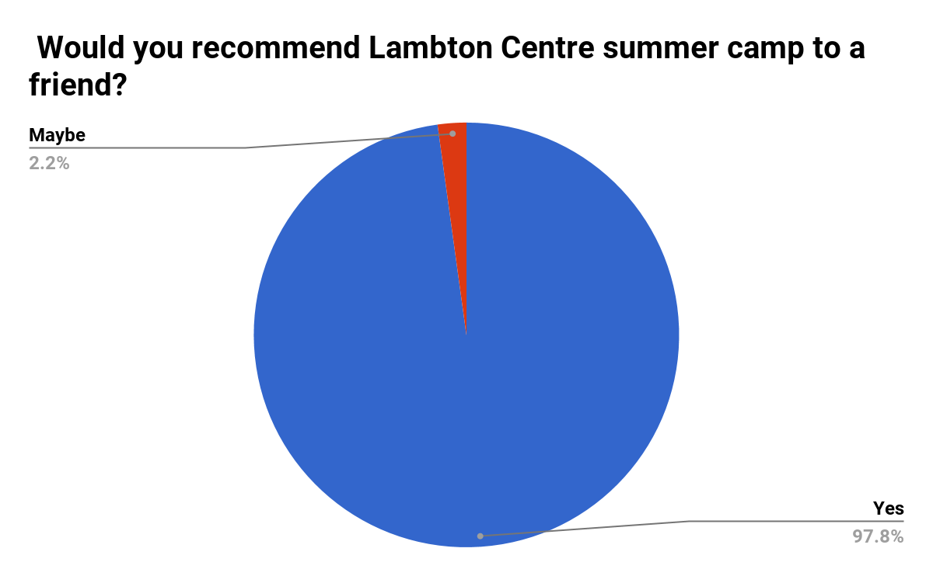
Would you recommend this camp to a friend?
This, at the end of the day is what is most important for campers and those of us who love to share the summer camp experience with young campers.

Reflections for 2018
Lambton Centre has
a great program and it was exciting to be able to be part of this program. As I look ahead I am excited to build on our program and add some more adventures for next year. Some of these ideas include:
- Developing our wilderness experience both for existing camps and as a camp experience on its own.
- There is also an opportunity to market our facility more to smaller groups such as Guides and church groups for both wilderness camping and cabin camping. Particularly with the Children’s Centre.
- Finding ways to make use of the waterfront that is now available to us. We are currently seeking donations to sponsor a canoe program.
- I would like to find a way that we could have a program where campers gain some kind of certificate as part of their program (i.e. first aid, leadership program, canoeing…)
- With SPLASH camp the numbers made it difficult to schedule all campers in the pool each day. I would like to look at how we can maximise the pool time to accommodate all campers each day.
- I think we could look at introducing some cultural elements to provide a First Nation experience for campers.
- I plan to review how and where we advertise so that we invest our energy in areas that has the greatest potential for attracting new campers.

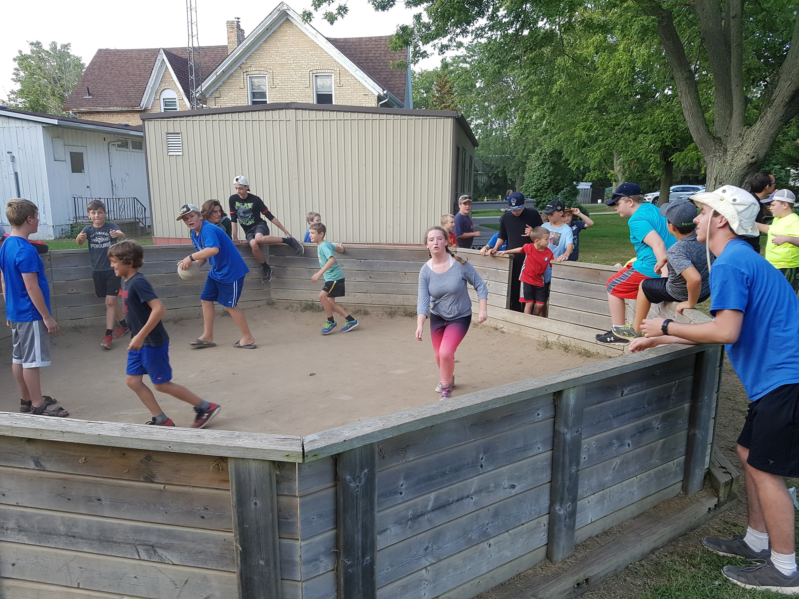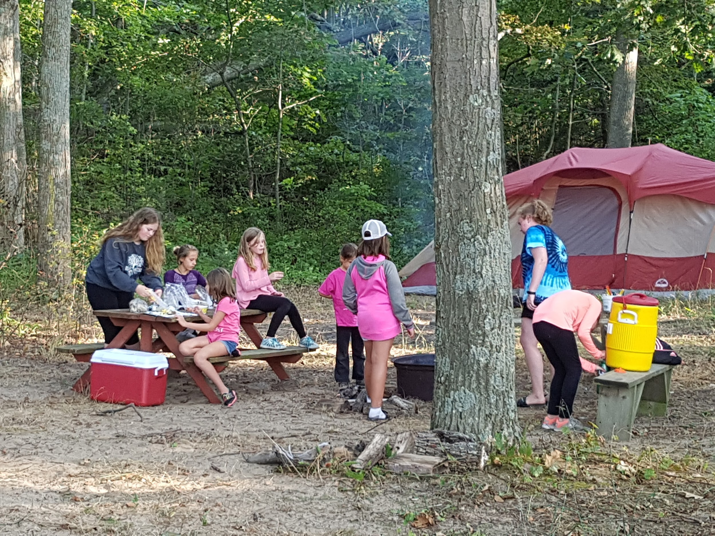

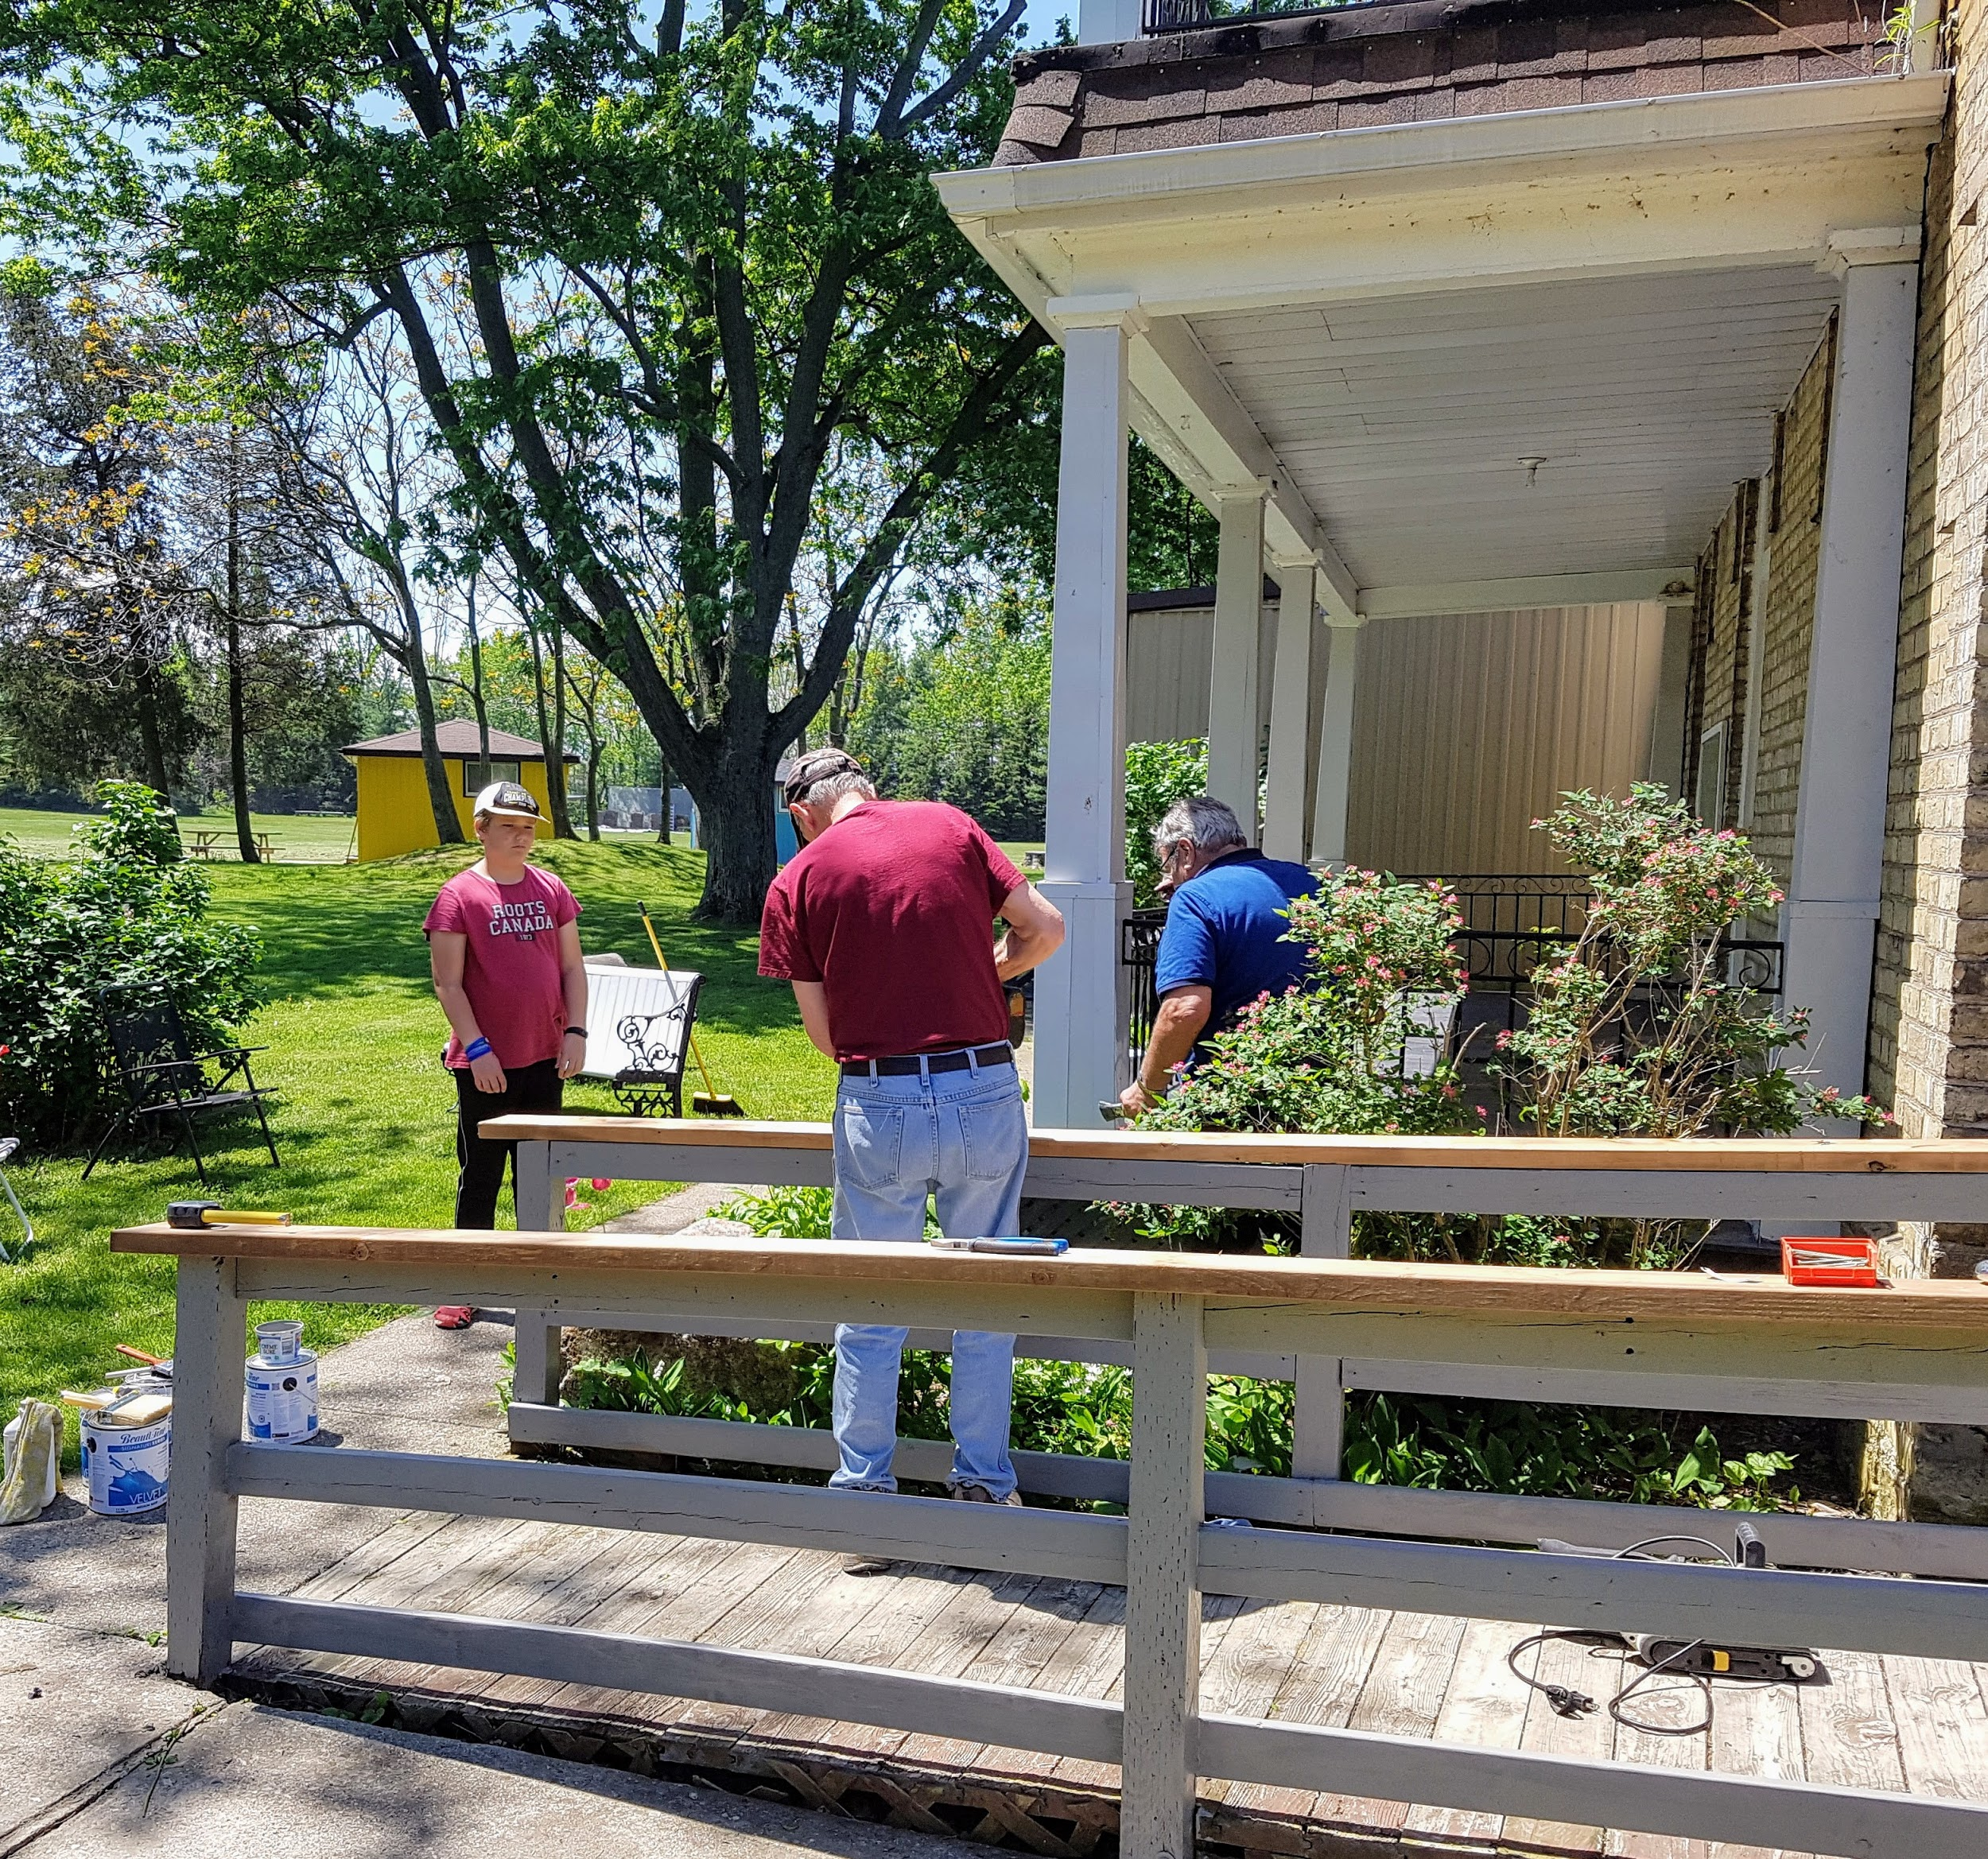
SEASONAL CAMPGROUND
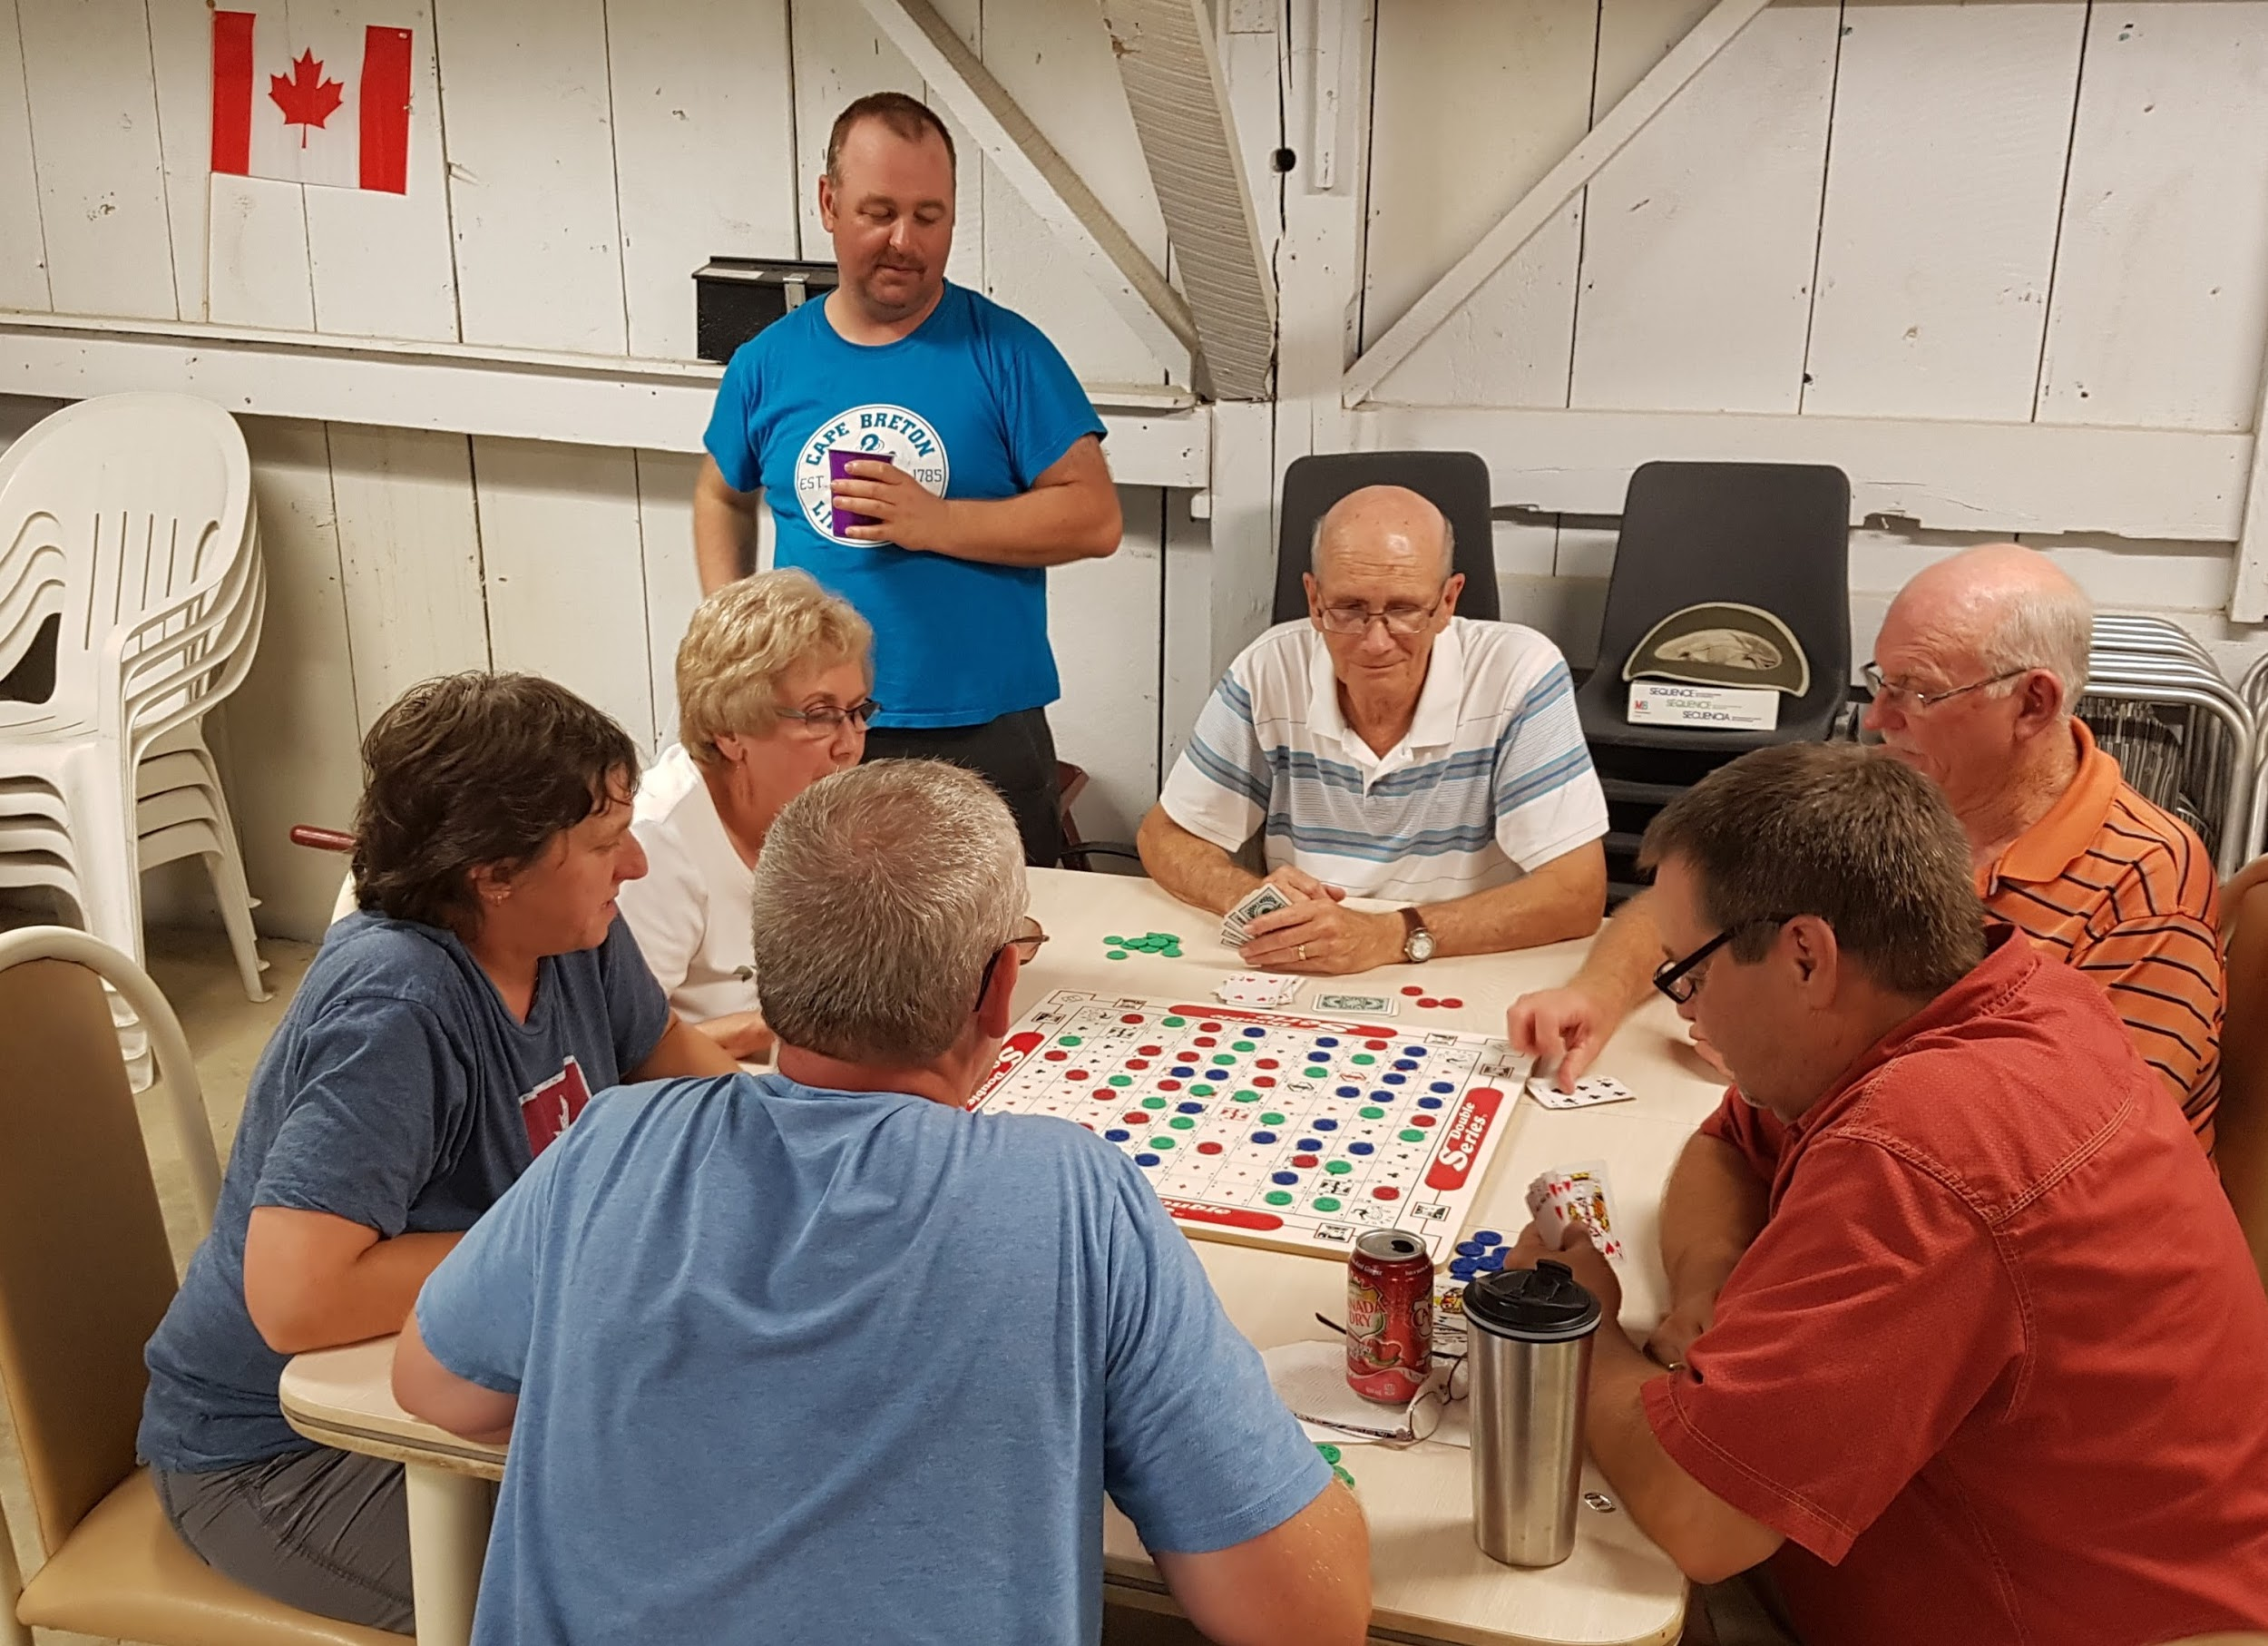
The Summer of 2017 was an exciting camping season at Lambton Centre. There are many fond memories of meeting new and interesting people along with celebrating Canada’s 150th with fireworks and a BBQ as well as potluck socials, to name a few. There were also challenges and maintenance issues like the water leak just days before the opening of the season. Volunteers and staff worked diligently to replace a leaking water line to all the trailers in “F” section.
As campers moved in for the summer, our new property manager Ben Gates and the Tuesday volunteers made sure that everything was working and ready for the summer. I quickly learned that it is no small feat to open a campground for the season. In the spring we completed another upgrade to the electrical grid at the east end of the trailer court, using funds from the reserve that campers contribute to each year. Gates hall was treated for the Post Powder Beetle. This will take a few years of repeat treatment to ensure that we can preserve the structural integrity of the building.

Perhaps one of the most memorable events was watching the sunset at the beach. Yes the beach, we have a beach again! For several year this view was blocked by the relentless growth of phragmites.
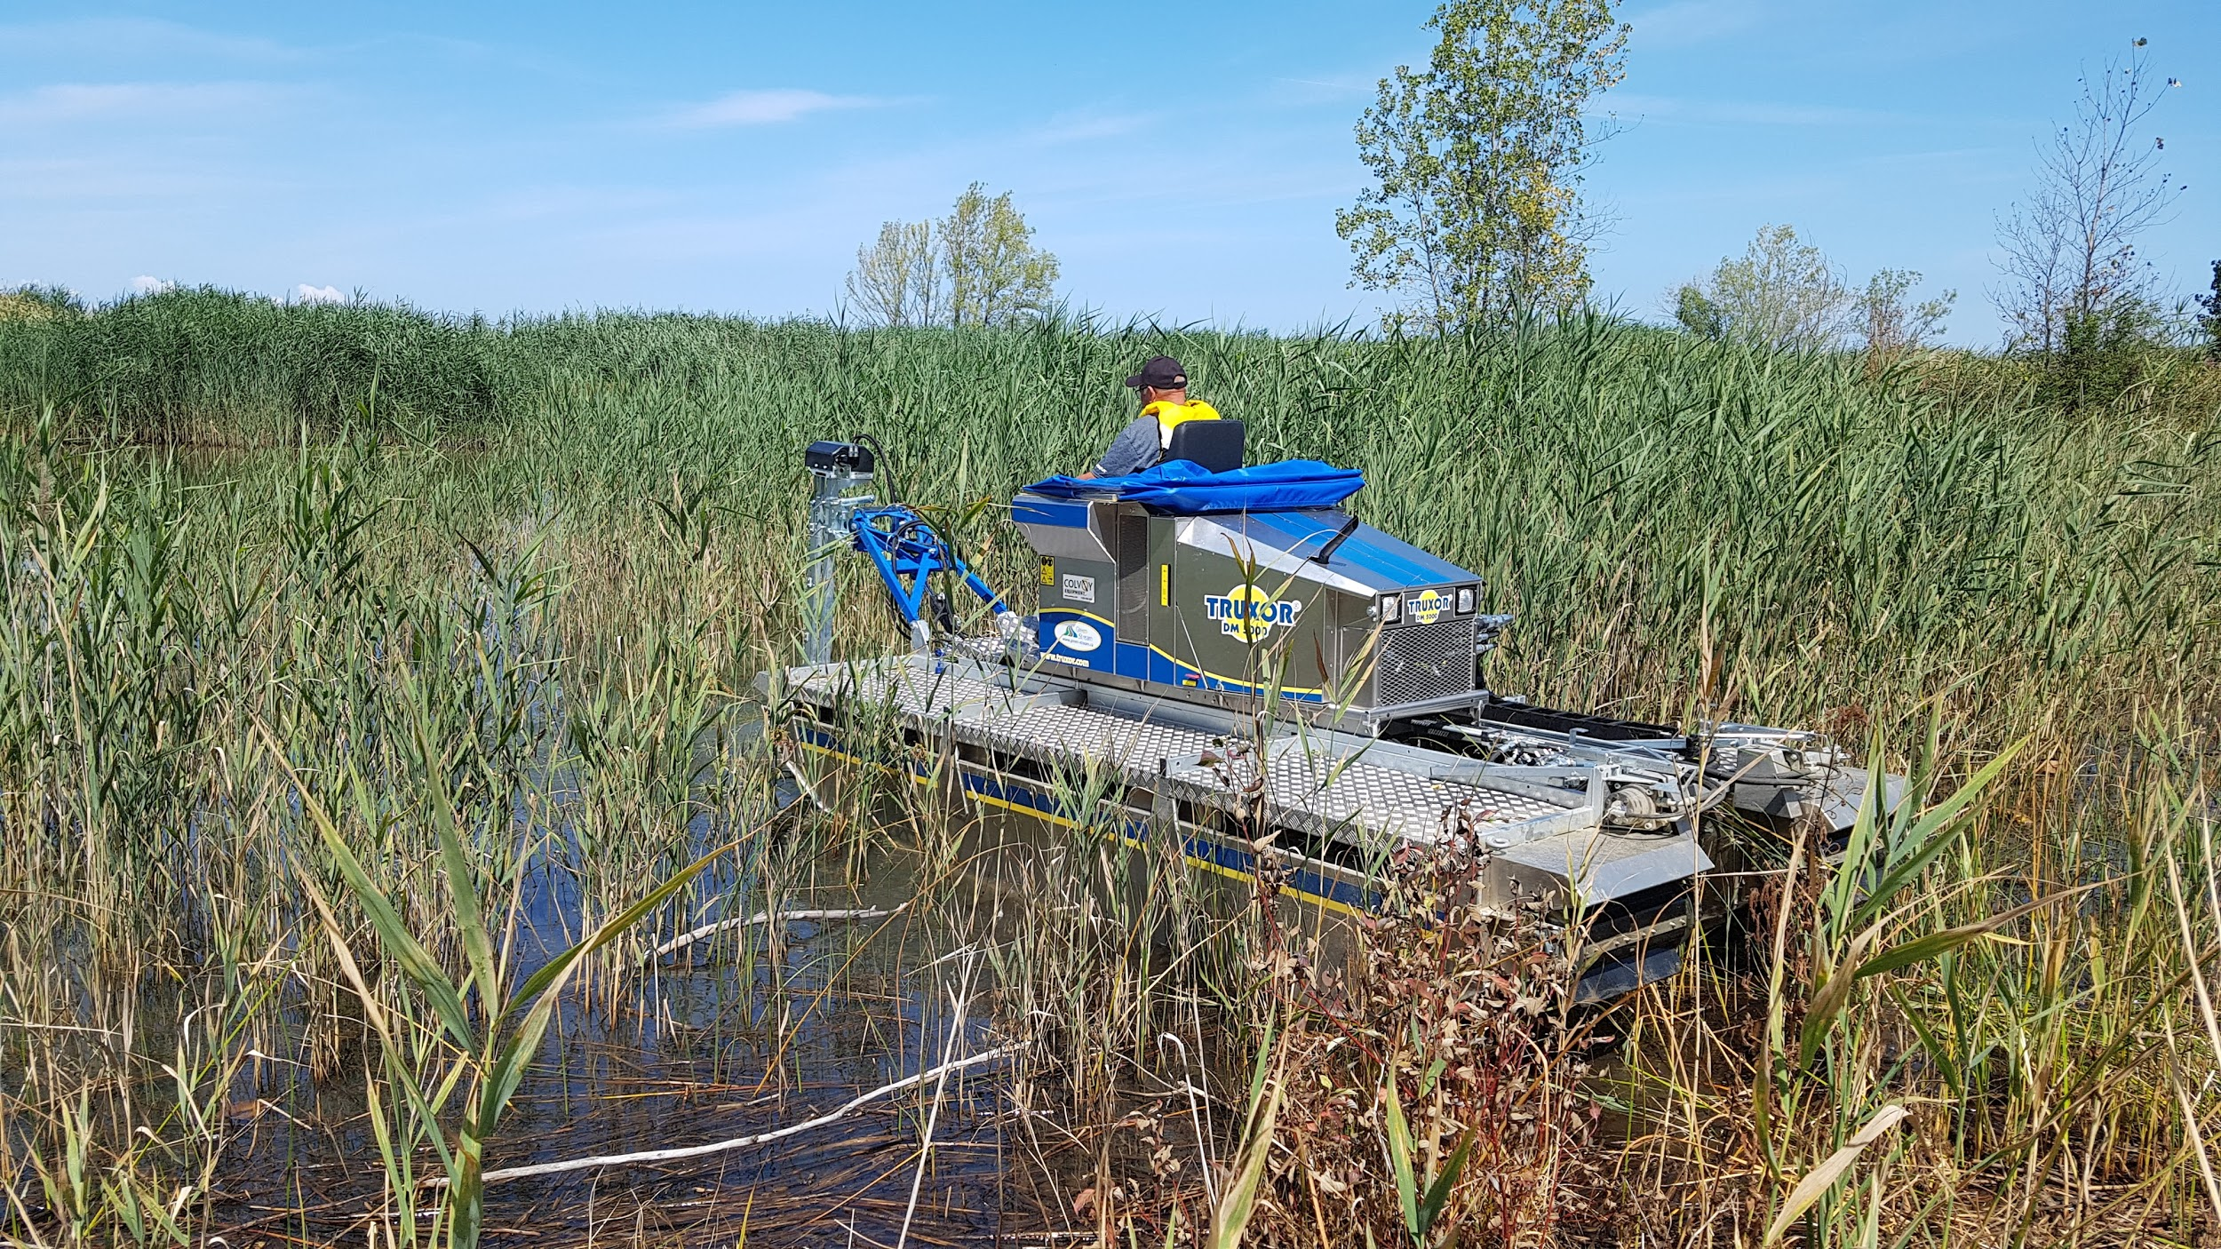
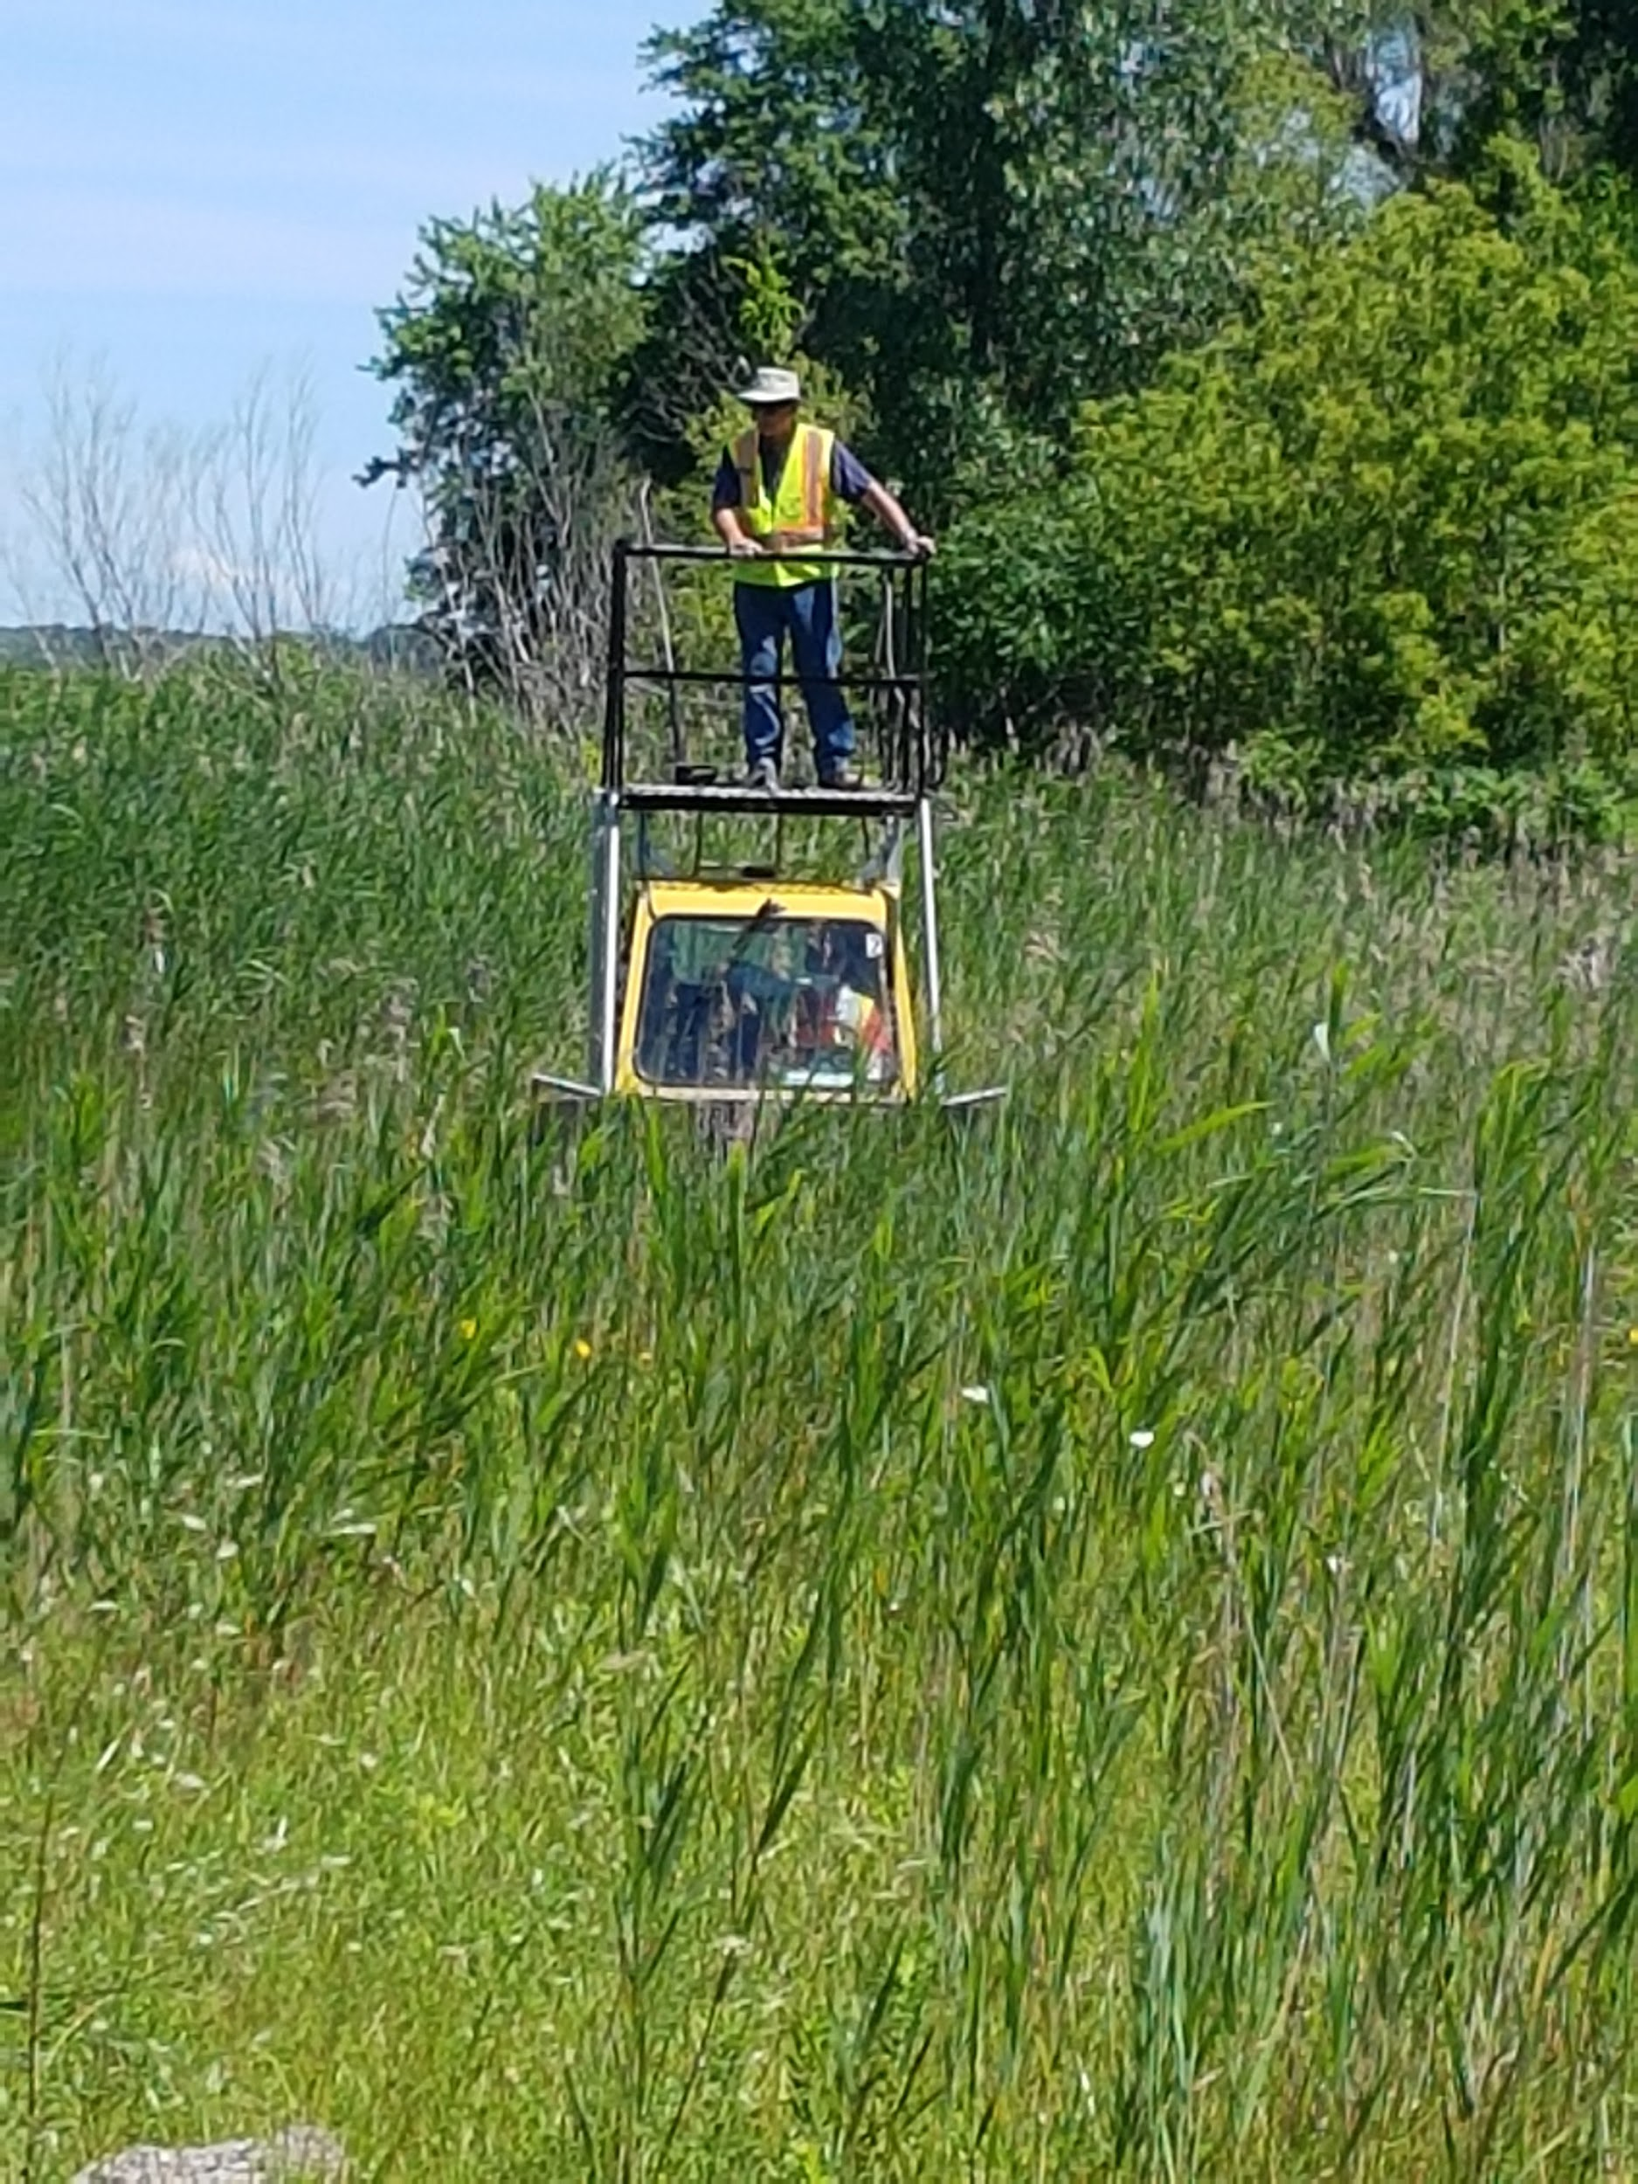
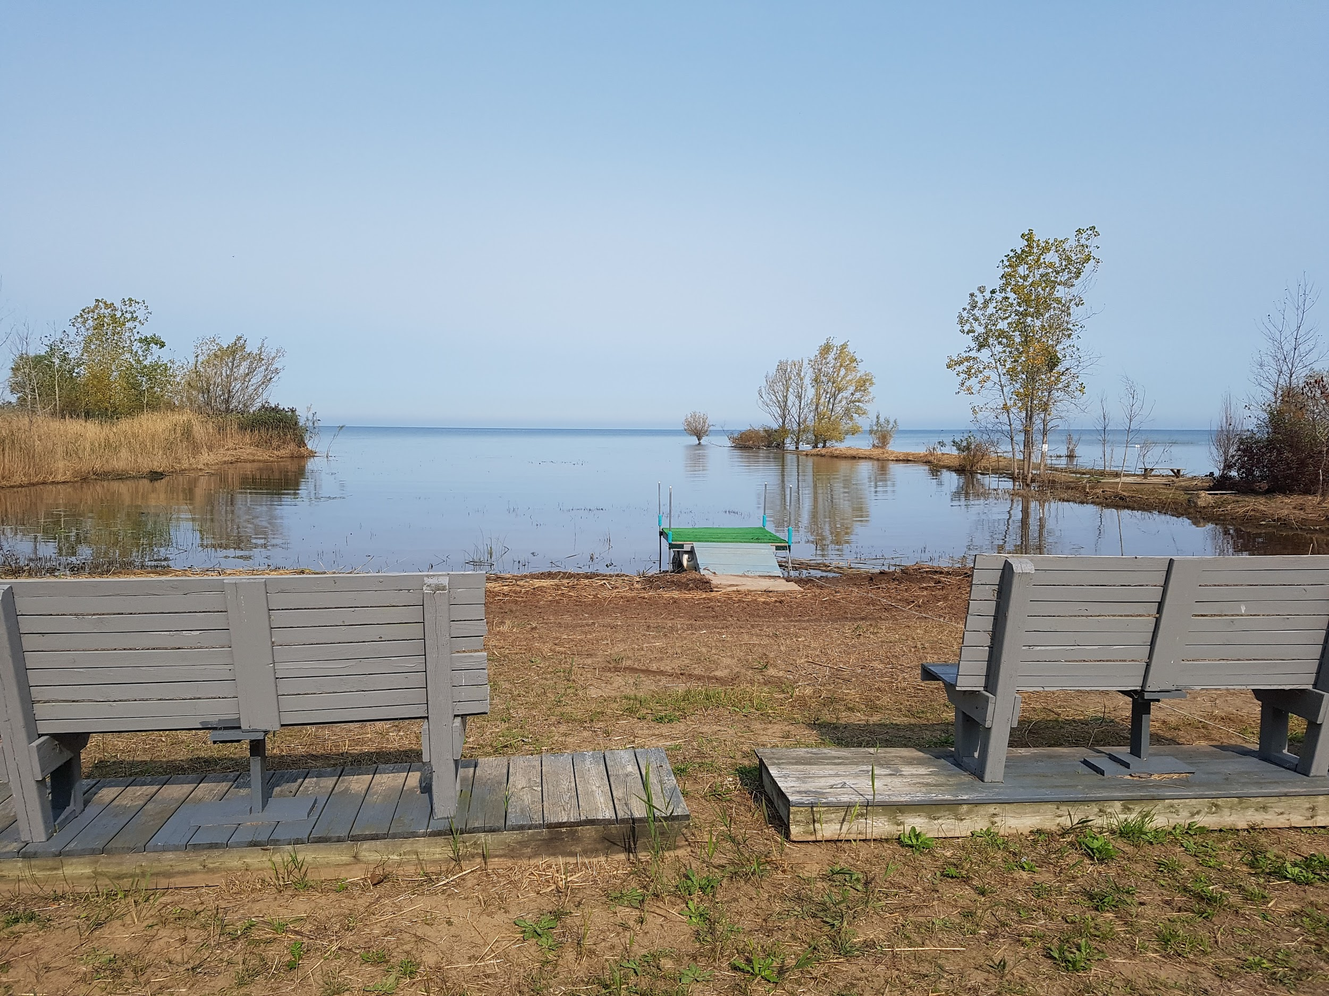
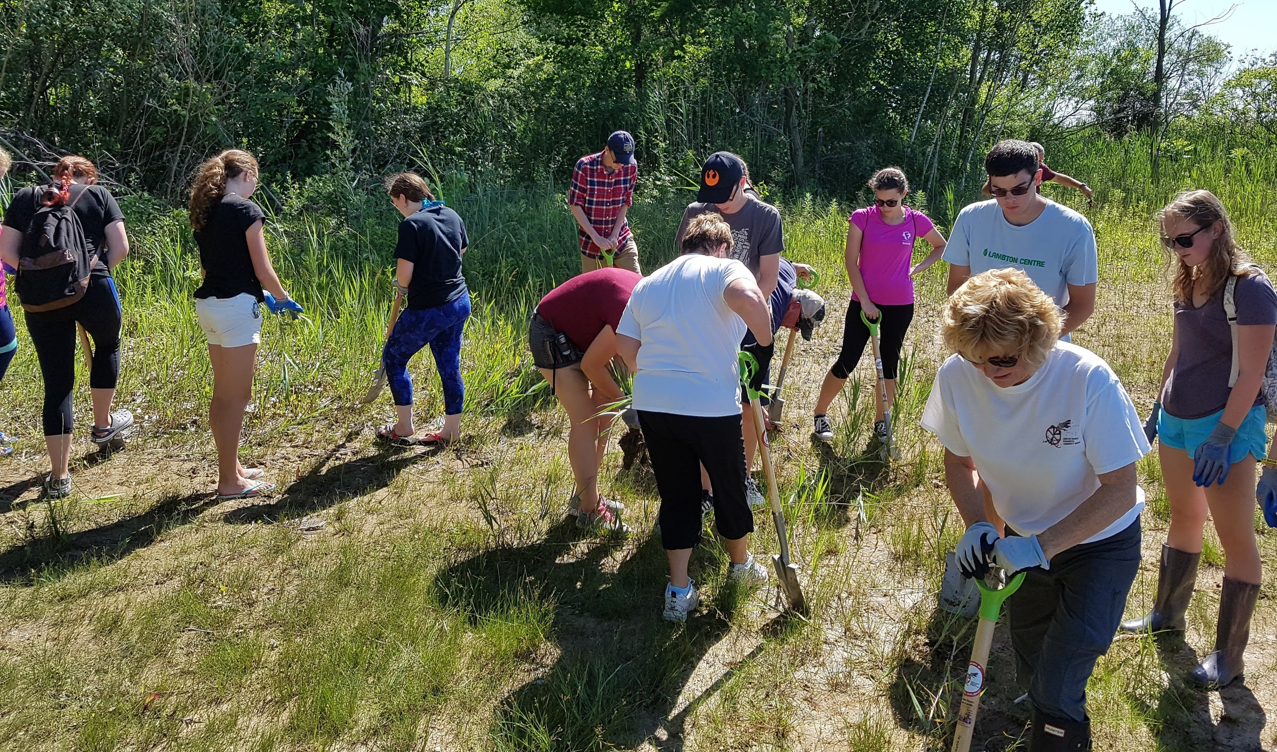
A special thanks needs to go out to Debby Merritt for all her work securing grants and networking with local phragmites committee. This summer we were able to cut and spray close to 12 acres of phragmites that was blocking access to the beach and lake. Specialized equipment like the Truxor and all terrain sprayer along with a host of volunteers with spades made it possible to regain access to the beach and lake at Lambton Centre. With the shore line open we have seen the return of different waterfowl, frogs, turtles and happy campers in canoes and kayaks. It is great to see the lake again, but Lambton Centre Staff and Board members are all aware that it will take an ongoing commitment to keep the phragmites under control so that we can keep our waterfront open.
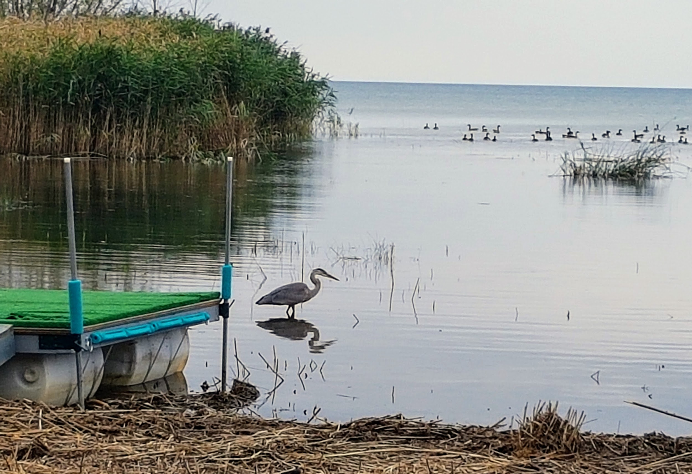
.

Although I have not conducted a formal survey of the seasonal campers, individual feedback and discussions at the two seasonal meetings have been quite positive and encouraging. In general, campers have found working with Ben to be very helpful and responsive to issues that arise from time to time.

Our seasonal numbers fluctuated over the season. We saw some long time campers move on and some new campers come into the campground. Over all we had 60 seasonal campers for most of the season. Some of the new campers have called Lambton Centre the best kept secret in Lambton County. Well we are letting the secret out, and look forward to seeing some new families in 2018! With the waterfront open, and some strategic marketing, we hope to welcome some new seasonal campers for the 2018 camping season. As part of the sharing of our story, I have been offering to speak at church services and events in the community and I would be happy to speak at your events and functions.
It has been quite the adventure and I look forward to new adventures in 2018.

Rick Boerkamp M. Div.
Executive Director

2016/2017 Budget Preparation
Income | Sept. 2016 Actual | 2017 Budget | Sept. 2017 Actual | 2017/2018 Proposed | Comments
Donations | $ 80,886.84 | $ 45,000.00 | $ 72,039.87 | $42,500.00
Trailer Court
Seasonal Fees | $ 96,162.42 | $ 108,000.00 | $ 105,732.64 | $129,500.00 | Based on 70 seasonals
Sponsored Camping | $ 2,650.00 | $ 2,650.00 | $ 2,399.00 | $2,400.00
Season Reserve | $ 5,600.00 | $ 6,000.00 | $ 6,000.00 | $7,000.00
Extra Hydro | $ 210.40 | $ 200.00 | $ 315.00 | $300.00
Grass Cutting | $ 1,279.43 | $ 1,000.00 | $ 1,331.48 | $1,200.00
Pump Out | $ 37.24 |  | $ 35.40
Gate Cards | $ 841.21 | $ 800.00 | $ 1,133.00 | $1,500.00
Washer/Dryer | $ 225.00 | $ 300.00 | $ 687.75 | $500.00
Total for Trailer Court | $ 107,005.70 | $ 118,950.00 | $ 117,634.27 | $142,400.00
Group Fees
Children's Centre | $ 1,920.76 | $ 2,900.00 | $ 1,359.80 | $1,500.00
Farm House | $ 14,482.99 | $ 16,500.00 | $ 14,533.80 | $15,000.00
Main | $ 27,767.90 | $ 31,600.00 | $ 23,594.77 | $28,000.00
Total Group Fees | $ 44,171.65 | $ 51,000.00 | $ 39,488.37 | $44,500.00
Outdoor Education | $ 13,858.11 | $ 13,500.00 | $ 10,915.66 | $13,500.00 | Based on 1,000 kids
Summer Camp
Fees | $ 51,038.65 | $ 53,500.00 | $ 56,066.91 | $64,000.00 | Adding a new camp
Bursary | $ 750.00 | $ 750.00 | $ 200.00 | $200.00
Busing |  |  |  | $3,000.00
Total Summer Camp | $ 51,788.65 | $ 54,250.00 | $ 56,266.91 | $67,200.00
Income | Sept. 2016 Actual | 2017 Budget | Sept. 2017 Actual | 2017/2018 Proposed | Comments
Misc. Sales |  |  | $ 1,266.22
Grants
RFTR | $ 2,810.00 | $ 2,810.00 | $ 3,870.00 | $3,870.00
Additional | $ 3,125.88 | $ 6,000.00 | $ 38,395.00 | $15,000.00
Capital Grant | $ 4,000.00 | $ 4,000.00 | $ 4,000.00 | $4,000.00
Student Employment | $ 33,270.00 | $ 15,000.00 | $ 22,484.00 | $15,000.00
Total Grants | $ 43,205.88 | $ 27,810.00 | $ 68,749.00 | $37,870.00
Lambton Presbytery | $ 31,000.00 | $ 31,000.00 | $ 31,000.00 | $31,000.00
Interest | $ 169.38 |  | $ 171.02
Fundraising
BBQ | $ 1,795.98 |  | $ 4,839.66 | $5,000.00 | $3,000.00 for Chicken  $2,000.00 Pork and Beef
Cross Country | $ 840.59 |  | $ 560.16 | $385.00 | Balance is in Outdoor  Education
Fall Night Out | $ 1,010.61 |  | $ 1,440.89 | $3,100.00
Trivia Night | $ 877.49 |  | $ 1,669.00 | $1,700.00
Sarnia Sting |  |  |  | $948.00
New Fundraisers |  |  |  | $3,000.00
Total Fundraising | $ 4,524.67 | $ 7,000.00 | $ 8,509.71 | $14,133.00
Total Income | $ 377,496.24 | $ 349,510.00 | $ 407,297.08 | $394,353.00

Expenses | 2016 Actual | 2017 Budget | 2017 Actual | 2017 /2018 Proposed
Utilities
Hydro
Main | $ 17,185.04 | $ 19,000.00 | $ 13,899.21 | $13,600.00
Trailer Court | $ 11,678.05 | $ 13,000.00 | $ 13,304.88 | $14,000.00
Childrens Centre | $ 2,951.12 | $ 2,700.00 | $ 2,245.62 | $2,350.00
Manse | $ 154.27 | $ 2,500.00 | $ 1,163.54 | $1,500.00
Total Hydro | $ 31,968.48 | $ 37,200.00 | $ 30,613.25 | $31,450.00
Propane/Oil
Kitchen Propane | $ 1,377.00 | $ 1,200.00 | $ 831.73 | $1,000.00 | No receipts for outdoor bbq's
Mobile Propane | $ 1,614.62 | $ 1,400.00 | $ 1,419.92 | $1,600.00 | Will be occupied for 12 months this fiscal year
Farm House/Main Oil | $ 2,943.93 | $ 3,000.00 | $ 3,297.49 | $3,500.00
Total Hydro | $ 5,935.55 | $ 5,600.00 | $ 5,549.14 | $6,100.00
Water | $ 1,656.49 | $ 1,200.00 | $ 1,099.54 | $1,400.00 | Ben found 2 leaks, will be  taken care of in the spring
Property Taxes | $ 24,996.91 | $ 25,500.00 | $ 25,440.87 | $26,500.00
Property Insurance | $ 17,083.08 | $ 17,200.00 | $ 16,130.02 | $16,000.00 | We have received our  renewal for next year
Travel
Volunteer & Board | $ 11,101.06 | $ 10,000.00 | $ 13,664.92 | $13,500.00
Employee | $ 1,209.41 | $ 1,200.00 | $ 1,014.13 | $2,000.00
Total | $ 12,310.47 | $ 11,200.00 | $ 14,679.05 | $15,500.00

Expenses | 2016 Actual | 2017 Budget | 2017 Actual | 2017 /2018 Proposed
Bank Service Charges | $ 970.65 | $ 1,000.00 | $ 1,015.24 | $1,200.00
Credit Card Service Charges | $ 2,141.00 | $ 2,700.00 | $ 2,639.71 | $2,800.00
Service Contracts | $ 1,748.02 | $ 1,750.00 | $ 1,308.08 | $1,400.00
Postage | $ 324.58 | $ 350.00 | $ 332.50 | $400.00
Food Costs | $ 811.57 | $ 500.00 | $ 474.51 | $500.00
Office Supplies | $ 1,643.08 | $ 1,200.00 | $ 941.58 | $1,000.00
Telephone & WiFi | $ 3,047.37 | $ 3,100.00 | $ 2,986.00 | $3,425.00
Total | $ 16,912.28 | $ 17,100.00 | $ 15,694.96 | $16,925.00
Memberships | $ 172.85 | $ 950.00 | $ 1,009.16 | $0.00
Advertising | $ 4,067.96 | $ 2,000.00 | $ 1,470.90 | $3,000.00
Public Relations | $ 1,030.00 | $ 1,000.00 | $ 655.62 | $1,500.00
Totals | $ 5,270.81 | $ 3,950.00 | $ 3,135.68 | $4,500.00
Building & Grounds
Capital Expenditures | $ 58,504.68 | $ 15,000.00 | $ 17,374.73 | $8,000.00
House Upkeep |  |  | $ 753.22 | $1,000.00
Janitorial Supplies | $ 1,500.31 | $ 1,500.00 | $ 1,712.47 | $1,800.00
Mobile Home Expense
Phragmites Control |  |  | $ 34,864.46 | $1,000.00
Repairs & Maintenance | $ 16,088.04 | $ 22,000.00 | $ 23,173.35 | $28,000.00
Gas/Propane | $ 1,439.34 | $ 1,500.00 | $ 2,854.21 | $3,200.00
Waste Removal | $ 1,115.60 | $ 1,200.00 | $ 1,225.76 | $1,250.00
Pool Operating Expense | $ 1,626.60 | $ 1,700.00 | $ 968.68 | $2,000.00 | There will be 2 pool  closures in 2017/2018  fiscal year
Tractor |  | $ 8,000.00 | $ 8,012.64 | $8,012.64
Totals | $ 80,274.57 | $ 50,900.00 | $ 90,939.52 | $54,262.64
Expenses | 2016 Actual | 2017 Budget | 2017 Actual | 2017 /2018 Proposed
Main | $ 81,425.93 | $ 70,000.00 | $ 77,620.11 | $110,000.00
Custodian | $ 13,144.04 | $ 16,000.00 | $ 18,364.32 | $19,500.00
Contract | $ 168.00 | $ 500.00 | $ 244.50 | $0.00
Summer  Maintenance |  | $ 3,500.00 | $ - | $4,000.00 | For the phragmites and the  beach area in 2017/2018
Totals | $ 94,737.97 | $ 90,000.00 | $ 96,228.93 | $133,500.00
Summer Wages
Summer Lifeguard | $ 2,219.00 | $ 2,950.00 | $ 3,639.00 | $4,000.00
Seasonal Grass | $ 105.30 |  | No one hired in 2017 | $0.00
Cook/Assistant | $ 4,286.25 | $ 4,750.00 | $ 4,657.88 | $6,300.00 | Assistant cook will also act as  an additional counsellor
Counsellors | $ 14,245.88 | $ 18,400.00 | $ 18,448.41 | $19,480.00 | 11 counsellors
Head Counsellors
Senior Staff | $ 14,955.40 | $ 15,000.00 | $ 13,017.30 | $16,750.00
Summer Camp Director | $ 7,896.25 | $ 10,000.00 | No one hired in 2017 | $0.00 | Senior Staff will assist  Executive Director
Vacation Pay | $ 1,737.43 | $ 2,184.00 | $ 1,562.19 | $1,861.20
Totals | $ 45,445.51 | $ 53,284.00 | $ 41,324.78 | $48,391.20
Employee Benefits
E.I. | $ 4,476.29 | $ 4,204.00 | $ 3,741.58 | $4,140.69
CPP | $ 6,303.28 | $ 7,095.00 | $ 5,939.90 | $6,595.00
Workers Comp | $ 1,275.53 | $ 1,075.00 | $ 3,806.60 | $4,609.00 | Re-classified Jan. 2017
Totals | $ 12,055.10 | $ 12,374.00 | $ 13,488.08 | $15,344.69

Expenses | 2016 Actual | 2017 Budget | 2017 Actual | 2017 /2018 Proposed
Capital | $ 213.56 | $ 8,000.00 | $ 9,306.62 | $8,000.00
Training | $ 851.23 | $ 500.00 | $ 1,063.12 | $1,100.00 | Adventure Works and RFTR
Food | $ 9,409.82 | $ 9,000.00 | $ 7,275.47 | $9,000.00
Program | $ 5,284.02 | $ 4,000.00 | $ 3,717.17 | $3,500.00
Supplies | $ 62.35 |  |  | $0.00
Tuck Shop |  |  |  | $300.00
T.Shirts | $ 1,789.93 | $ 1,800.00 | $ 2,022.07 | $2,100.00
Totals | $ 17,610.91 | $ 23,300.00 | $ 23,384.45 | $24,000.00
Expenses | $ 366,258.13 | $ 348,808.00 | $ 377,708.27 | $393,873.53 | Did

Difference: $479.47

Budget Discussion and Anticipated Upcoming Expenses

Income
- Last year there was a large donation made after the closing of Mandaumin United Church.
- Seasonal fees are based on 70 sites rented. Currently have 59 sites rented for the season. This leaves us 11 sites to rent to make budget.
- Group fees. We are going to try to promote more the rental facilities available at Lambton Centre. This would include within our churches and with outside groups such as guiding, boy scouts. We are hoping to increase bookings by at least 4 more rental nights in each of the 3 areas: Children’s Centre, Farm house and Main facilities. We are hoping to develop a relationship with Girl Guides of Canada.
- Outdoor education: we are estimating 1000 students at $13.50 per student
- Summer camp:
  - we will be receiving a donation from London Road West United to help supplement the busing fee for splash camp
  - Plan on trying to add an extra week of camp by combining two of our existing weeks: Teen week and Little People’s Week
- Grant amounts are very variable. Debby in the office has done a wonderful job on grant preparation and submission. She has been very successful in the past year. These grants vary for pay supplements, to the playground, to expenses to help upgrade the current facilities. We would like to thank Debby for her dedication.
- Fundraising
  - Very successful fall dinner this year. Approximately 200 people were served
  - Cross country revenue was decreased this year as there were less participants and the weather was poor.
  - We added a fundraising night at The Sarnia Sting Game which was very successful. Hopefully next year we will be able to advertise this night earlier to make it even more successful.
  - Looking for new and innovative ideas for fundraising
  - We are budgeting $7000 for this area of income

Building and Grounds
- Need to continually work on phragmites at Lambton Centre. We still have about 5 acres of phragmites that need to be removed but unless we can secure additional funding this year we will focus on maintaining the newly cleared beach area.
- Repairs and maintenance – need to work on some upgrades to the Children’s Centre and some of the other smaller buildings on site.
Summer Wages
- Maintenance – we have added a summer position to help with Phragmites control and assist Ben with additional products
- Counsellors – looking at approximately 11 counsellors and Junior Counsellors.
- Will look at hiring cook and possible assistant cook. The assistant cook would also possibly be a counsellor
- Summer Senior Staff: Program Director, Christian Education Director/Leader in Training director, Health Care Provider/ Integration co-ordinator
Summer Camp Capital Expenses Anticipated
- Canoes and supply to enjoy the waterfront: have some sponsorship for canoe packages from a few local service clubs.
- Development of Wilderness Camping: We would like to try to redevelop the wilderness area by Chapel Hill. This would allow another area for camp outs and to develop opportunities for more wilderness camp skills.

New Business

- As a Board we need to work on recruiting new member and volunteers. We need new board members, volunteers to help with fundraising opportunities and we need more help with maintenance at Lambton Centre. If anyone has suggestions, please let us know.
- Fundraising is always a main concern but it is even more important as we are uncertain of our continued financial support from the United Church as a whole, due to restructuring. We need to determine ways to seek individual support from United Churches within Lambton County. We are also looking for new and innovative ways to raise funds to help support the Centre. Ideas are always welcome.
- The Lambton Centre Board is also looking at suggestions of other groups to try to partner with to encourage weekend rentals. Potentially we could offer program support to these groups on weekends.
- Circle the Centre Work Bee Day
- Other comments, concerns or suggestions?

Thank you for joining us as members of Lambton United Church Centre at the AGM

One camper who used a wheelchair and required 1 on 1 support but was not supported through RFTR
We brought in one counsellor from Kinesarie
Extra program staff worked at painting, removing phragmites, staining chapel ramp and program support as needed.
Recruited counsellor from Pearce Williams, one LIT, and a LIT from 2016 Camp was full
Recruited one counsellor from Pearce Williams, one new counsellor, and one counsellor from last year. Rick covered chapel and LAUNCH programs
In 2015 there were 233 campers.

